   | University of Tsukuba  Graduate School of Life and Environmental Sciences  Division for Spatial Information Science (SIS)
Mobility and Urban Structure:
A Case Study of Four Asian Capital Cities
Konstantin GREGER, Yuji MURAYAMA
http://www.konstantingreger.net greger@geoenv.tsukuba.ac.jp
This study uses four movement data sets, provided by the Center for Spatial Information Science (CSIS) at the University of Tokyo. The data sets contain information about the movements of sample populations. These include the origin and destination of all trips, both regarding time and location, as well as the purpose of the trip and the modes of transportation per subtrip. In addition, the data sets also contain several socio-demographic attributes about the individuals, such as sex, age, and occupation.
Each data set in itself poses an immeasurable depth of information about the individual movements, the resulting mobility patterns, and their connection to the urban spatial structure of the city they occurred in. The comparison over all four these data sets promises to reveal even more interesting insights into the commonalities and differences among these four asian capital cities.
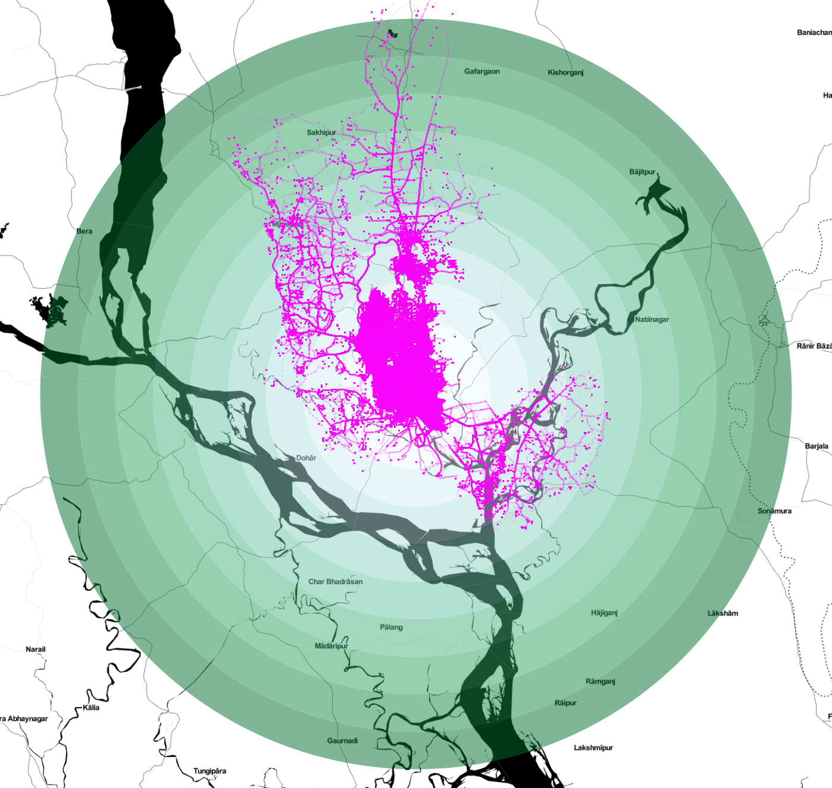  Dhaka  Data capture: 1.-2. October 2009  Individual persons: 42,114  Database size: 27.05 GB | 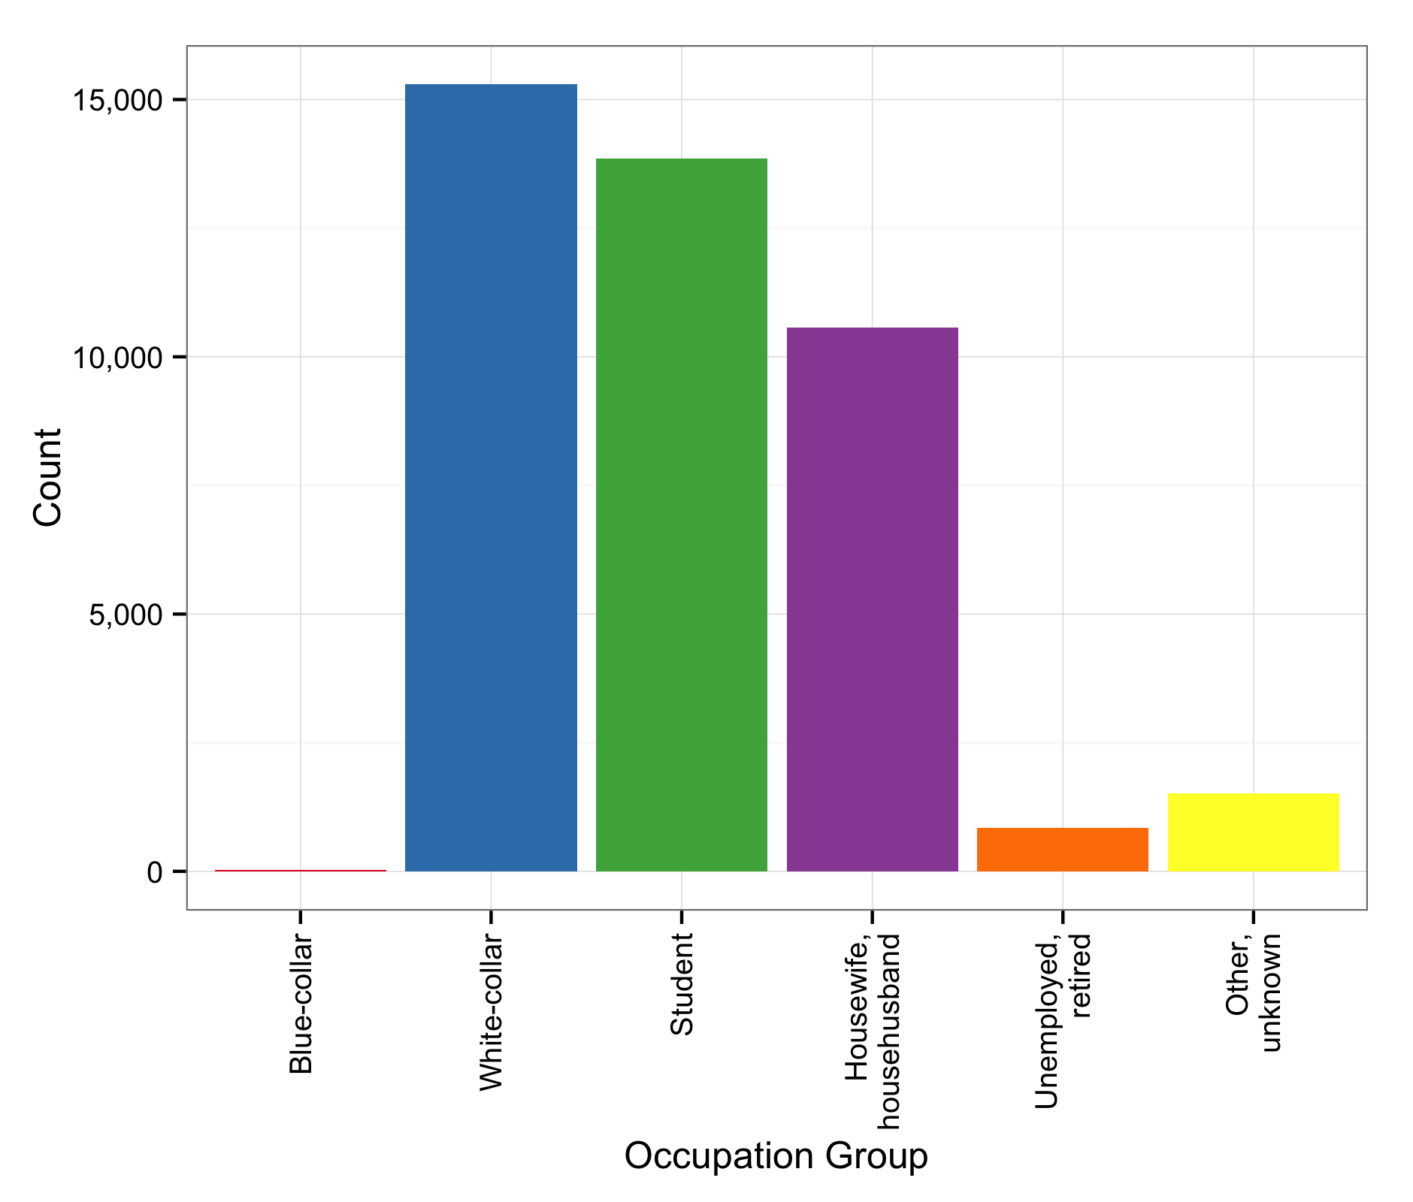 | 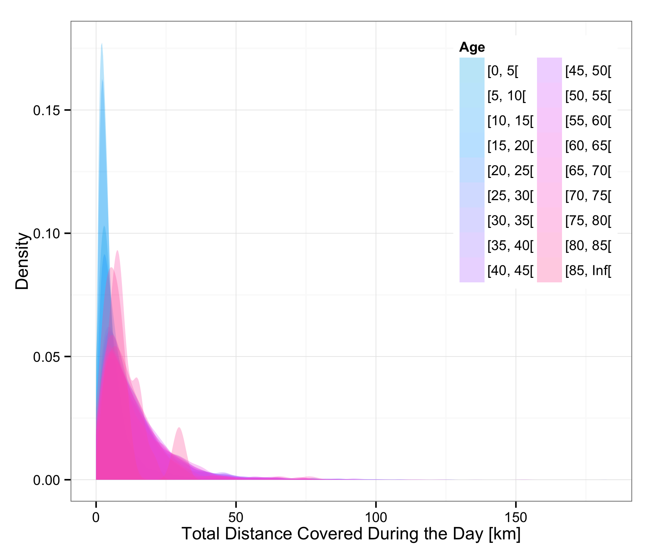 | 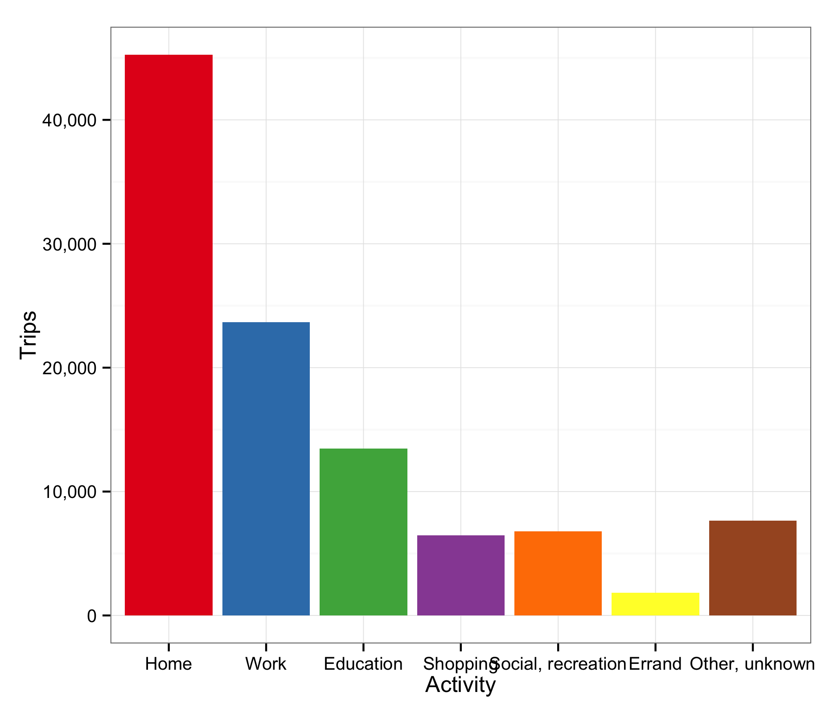 | 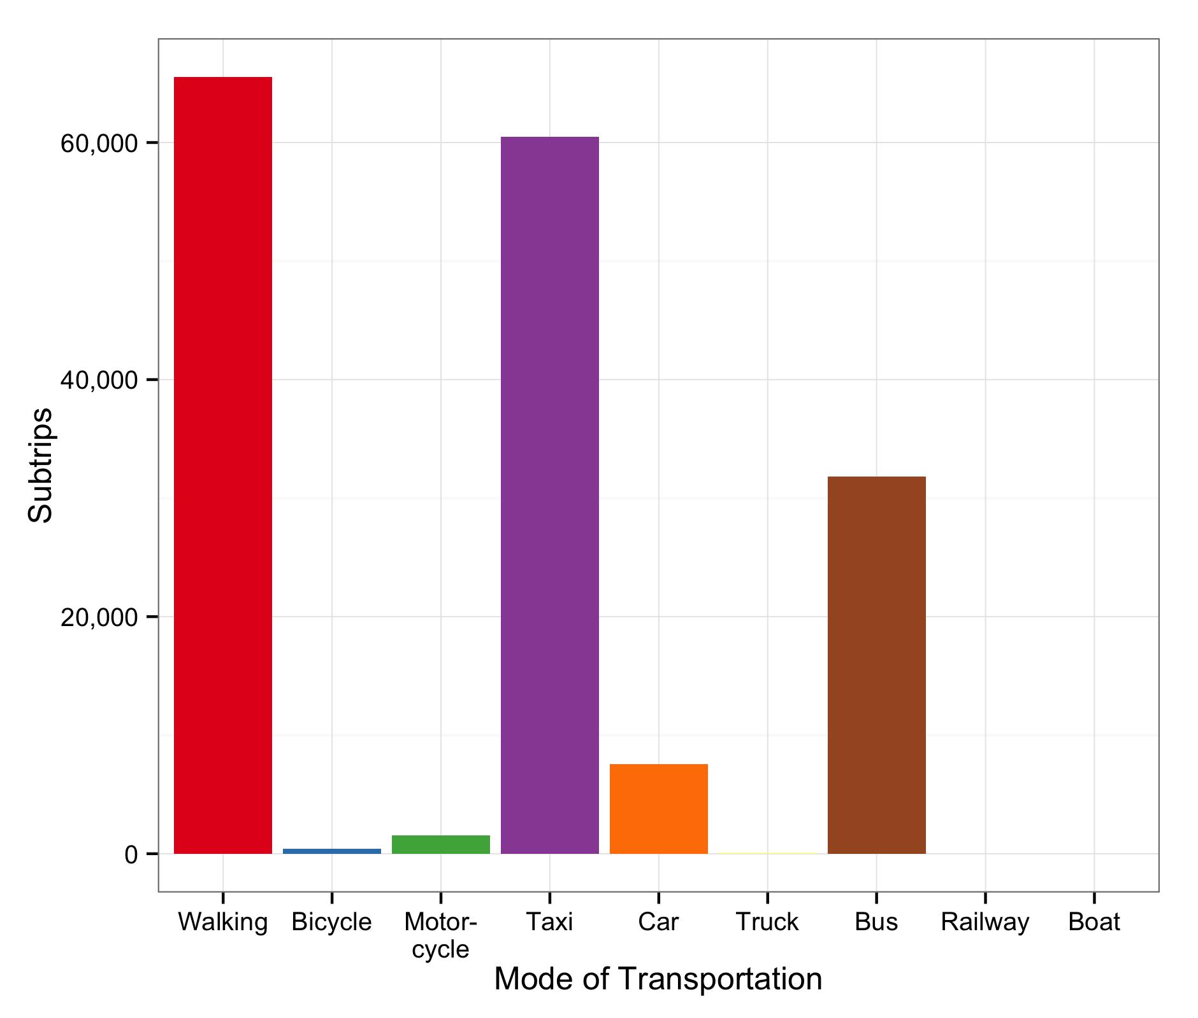 | At under 50,000 sample individuals the Dhaka data set is the smallest of the four. The distribution of occupations is very unbalanced with only 31 blue-collar workers and ca. 2% unemployed and retired. In contrast, white-collar workers, students, and housewives and househusbands form the majority at 36%, 33%, and 25%, respectively.  The data set from Hanoi contains data of ca. 60,000 people. The group of unemployed and retired is the most strongly represented in the sample at 28%, closely followed by white-collar workers at 27%. Students and blue-collar workers are also represented well in the sample at 21% and 15%, respectively.  The Jakarta data set is the largest in this study at almost 300,000 people. More than half of the people did not disclose their occupation. The remaining population consists of twice as many white-collar workers than blue-collar workers, only 3% students and no housewives and househusbands.  The data set for Manila, at ca. 200,000 people the second biggest, shows a strong presence of students (32%), followed by white-collar workers (28%), housewives and househus-bands (16%) and blue-collar workers (10%).  An analysis of the average total distance traveled over the 24-hour sampling period showed that younger people in Dhaka cover a rather short distance, often under 10 km, while a significant number of elderly people travel distances of 30 km or more per day. Almost half of these trips (43%) are homeward trips. At 26% trips to the working place are the most common, followed by trips to education institutions at 13%. In Hanoi and Jakarta the distributions of total trip distance shows a similar overall distribution, but no differences between the age groups. The data for Manila show a large number of very short trips.  The cities also show differences in the average commuting times. When separated for men and women as well as the morning and the evening commute the data also reveals interesting patterns:  The data from Dhaka and Manila show that the evening commute takes in average 6-7 minutes longer than the morning commute. In Hanoi and Jakarta the differences amount to only 2-4 minutes. Furthermore, Hanoi has not only the overall shortest commuting times (~20 minutes), but also the lowest number of subtrips these commuting trips consist of. This can be explained by the prevalence of motorcycles (40%), while in all other cities walking is the most common mode of transportation. In contrast taxis in Dhaka (36%), and buses in Jakarta and Manila (31% and 34%, respectively) represent the most common modes of transportation in their respec-tive cities.  A closer look at the number and purpose of subtrips started at every hour during the day also provides interesting insights into the commuting behavior in these asian capital cities. Dhaka shows a clear commuting trend before 12pm, both for work and education. A small peak of people returning home between 3am and 6am can be identified, most likely a result of shift work. Hanoi, Jakarta, and Manila all show clear signs of a shift system, both for work and education, albeit more pronounced in Hanoi, and mostly for students in Manila. All three have significant numbers of people returning home just before noon, only to be followed by a second wave of work- and education-bound trips a few hours later.  Finally we analyzed the spatial distribution of people over the course of the day in respect to their distance from the city center. For this purpose we created concentric ring buffers in 5 km distances and counted the absolute numbers of distinct people in each ring at each hour. Again the two-shift systems in Hanoi and Jakarta stand out with peaks of the numbers of people in the innermost buffers, while the data for Dhaka show only one pronounced commuting peak in the morning and another less pro-nounced peak in the evening, and also a large number of people in the city center over the course of the whole day.
  Dhaka |  | Mean duration | Mean subtrips |  | Hanoi |  | Mean duration | Mean subtrips
  All | morning | 34 min. | 1.6 |  | All | morning | 19 min. | 1.0
   | evening | 40 min. | 1.6 |  |  | evening | 20 min. | 1.0
  Men | morning | 36 min. | 1.6 |  | Men | morning | 20 min. | 1.0
   | evening | 42 min. | 1.6 |  |  | evening | 21 min. | 1.0
  Women | morning | 30 min. | 1.4 |  | Women | morning | 19 min. | 1.0
   | evening | 37 min. | 1.5 |  |  | evening | 20 min. | 1.0
  Jakarta |  | Mean duration | Mean subtrips |  | Metro Manila |  | Mean duration | Mean subtrips
  All | morning | 34 min. | 1.5 |  | All | morning | 31 min. | 1.8
   | evening | 37 min. | 1.6 |  |  | evening | 38 min. | 1.8
  Men | morning | 35 min. | 1.5 |  | Men | morning | 33 min. | 1.8
   | evening | 38 min. | 1.5 |  |  | evening | 40 min. | 1.8
  Women | morning | 32 min. | 1.5 |  | Women | morning | 29 min. | 1.8
   | evening | 36 min. | 1.6 |  |  | evening | 36 min. | 1.8
 | 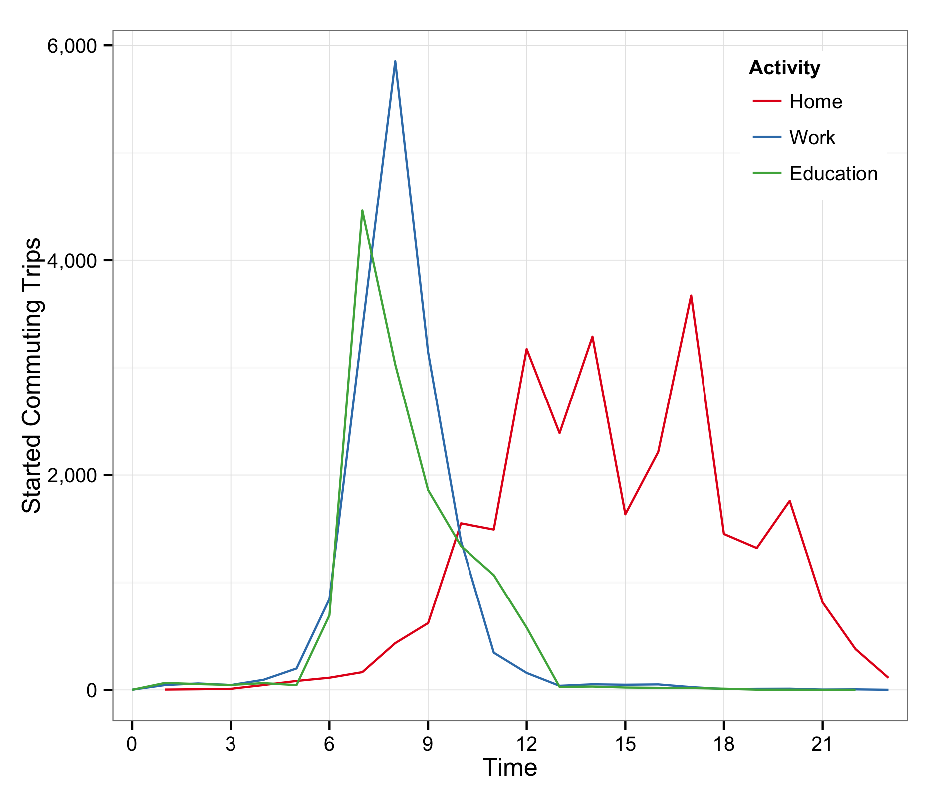 | 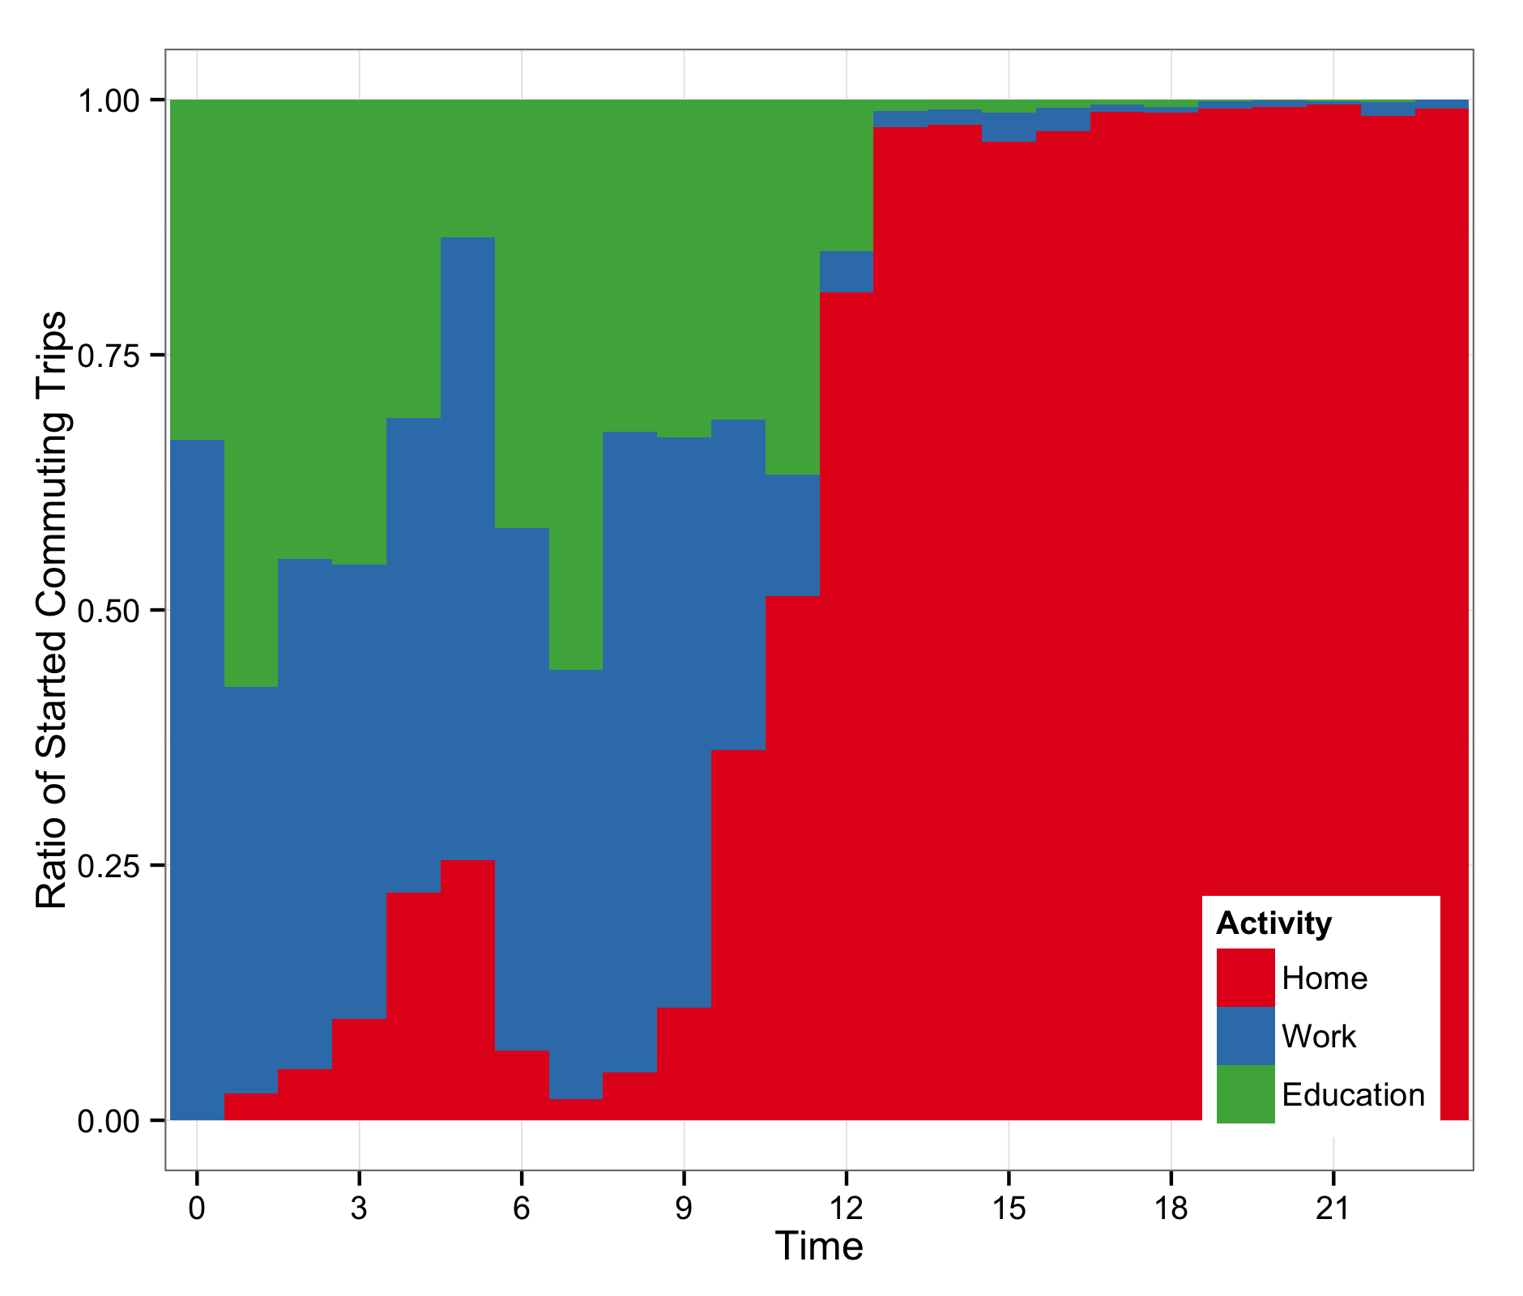 | 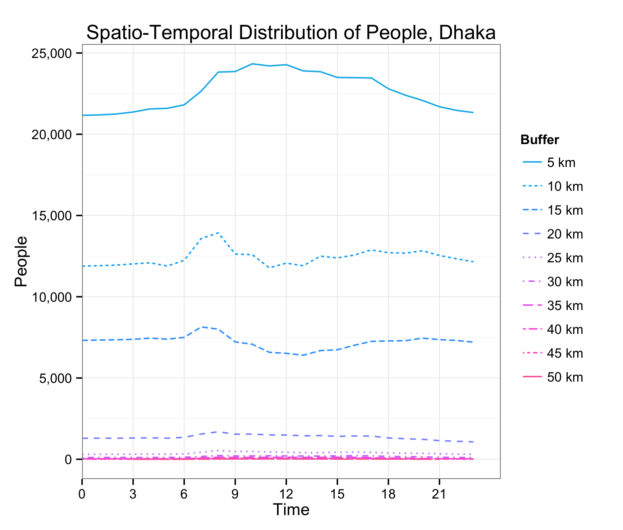 | 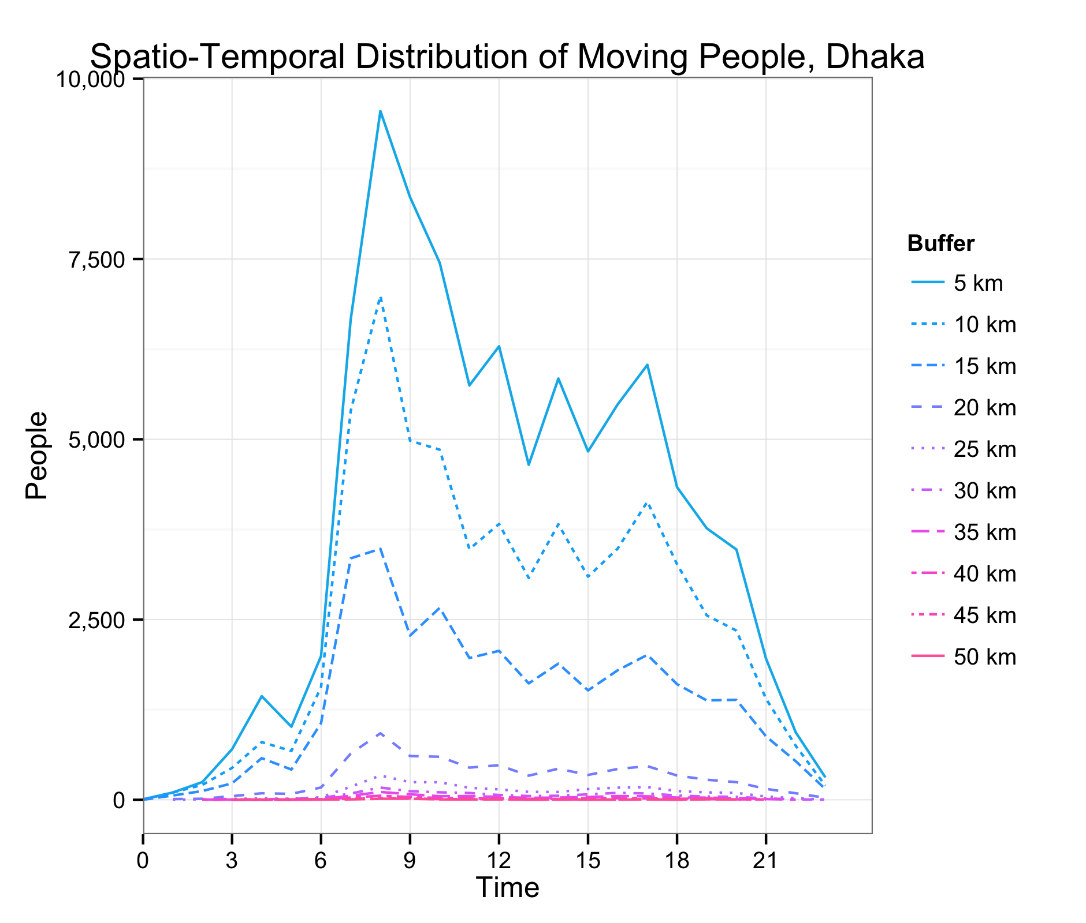
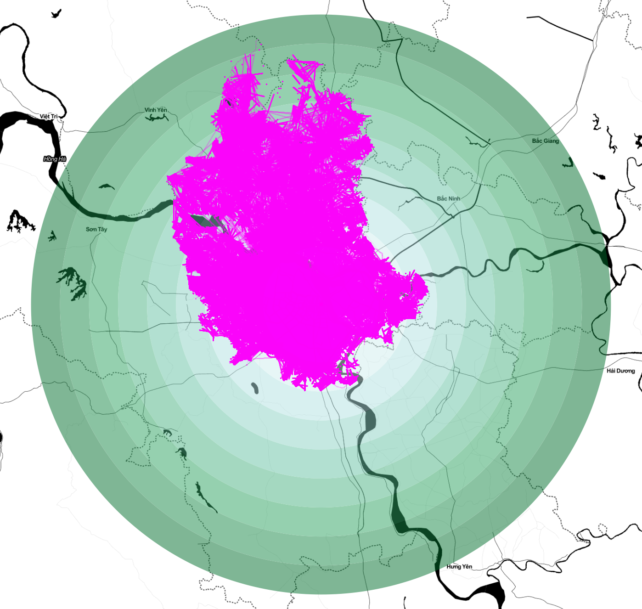  Hanoi  Data capture: 1.-2. October 2004  Individual persons: 58,018  Database size: 36.66 GB | 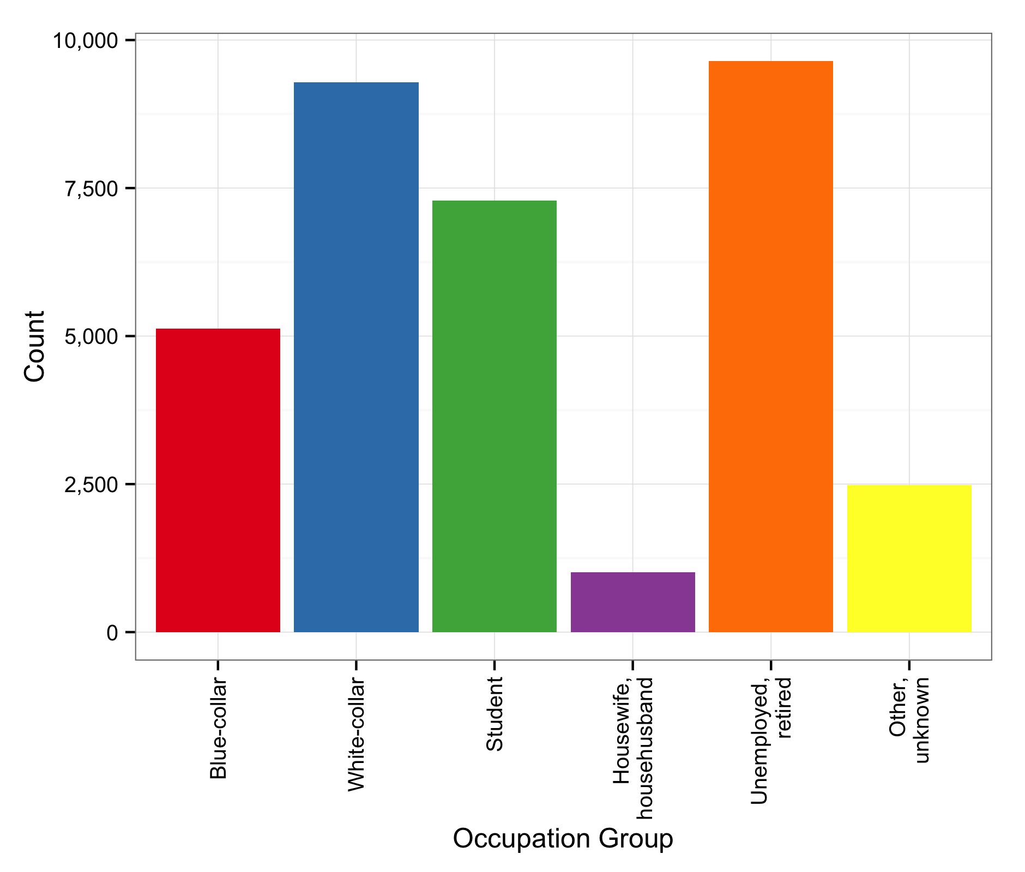 | 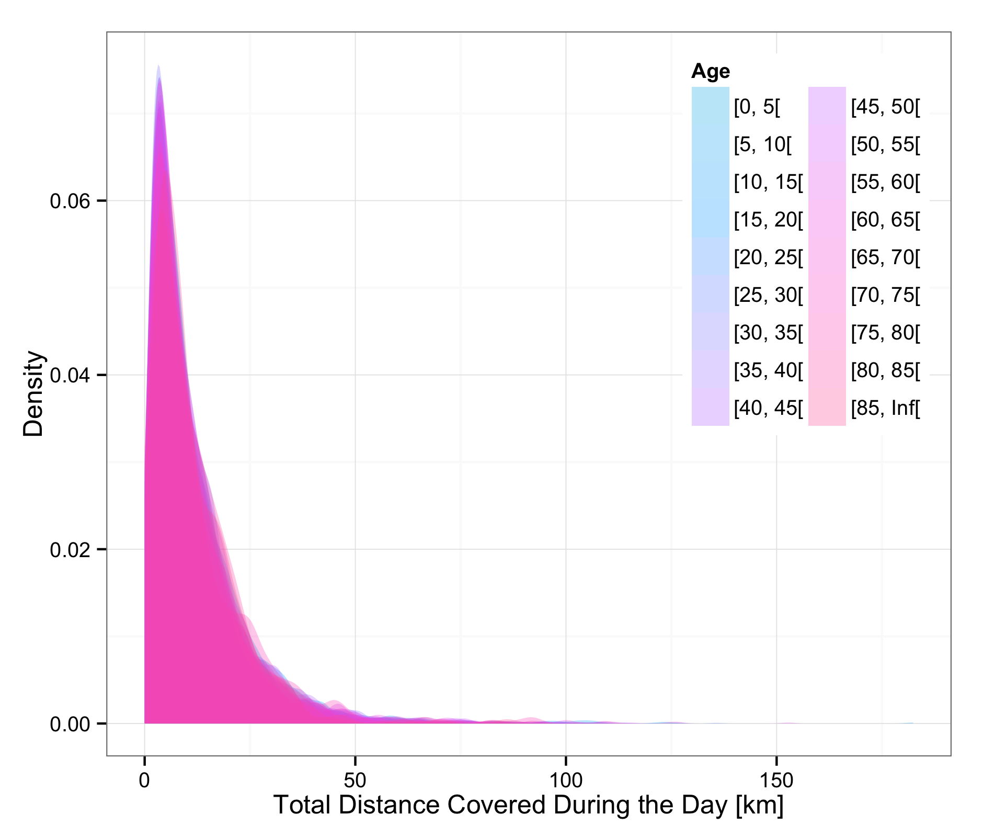 | 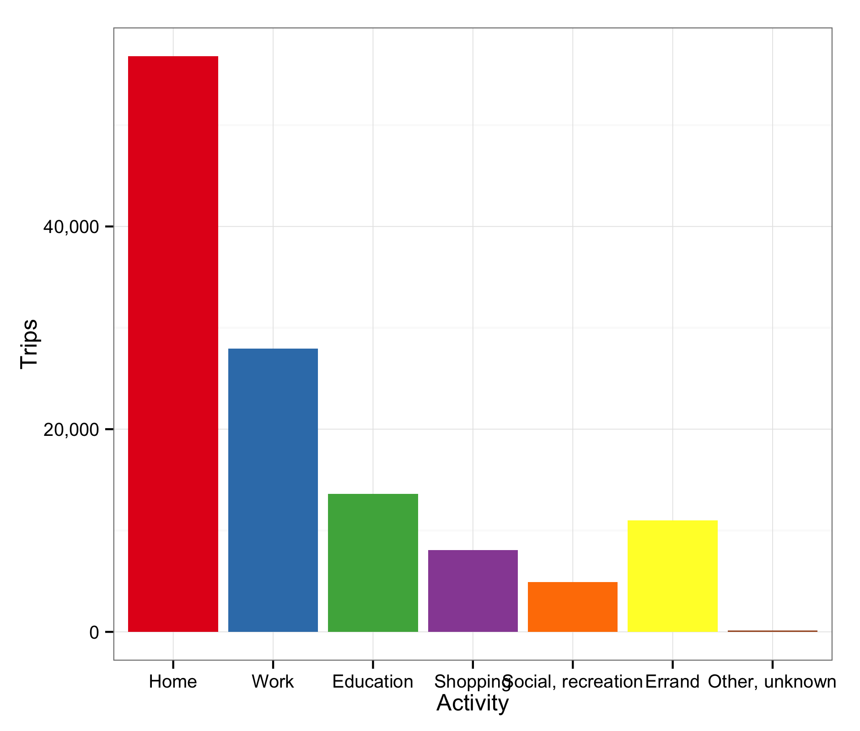 | 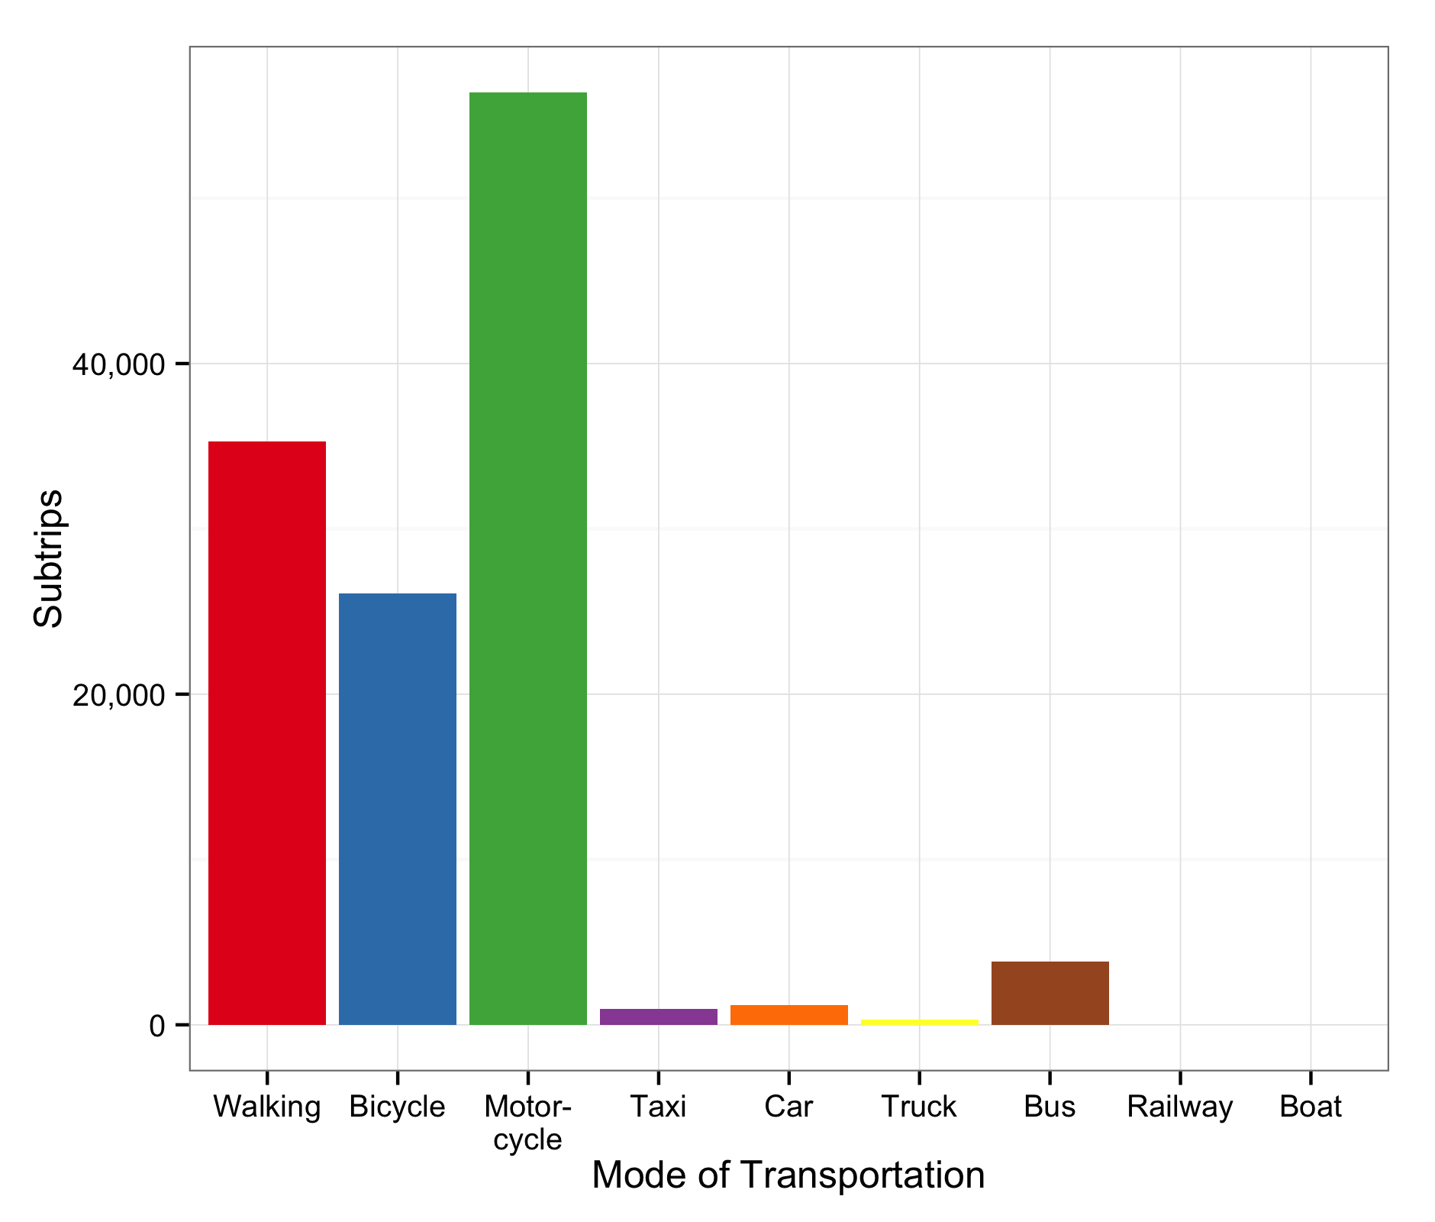
 | 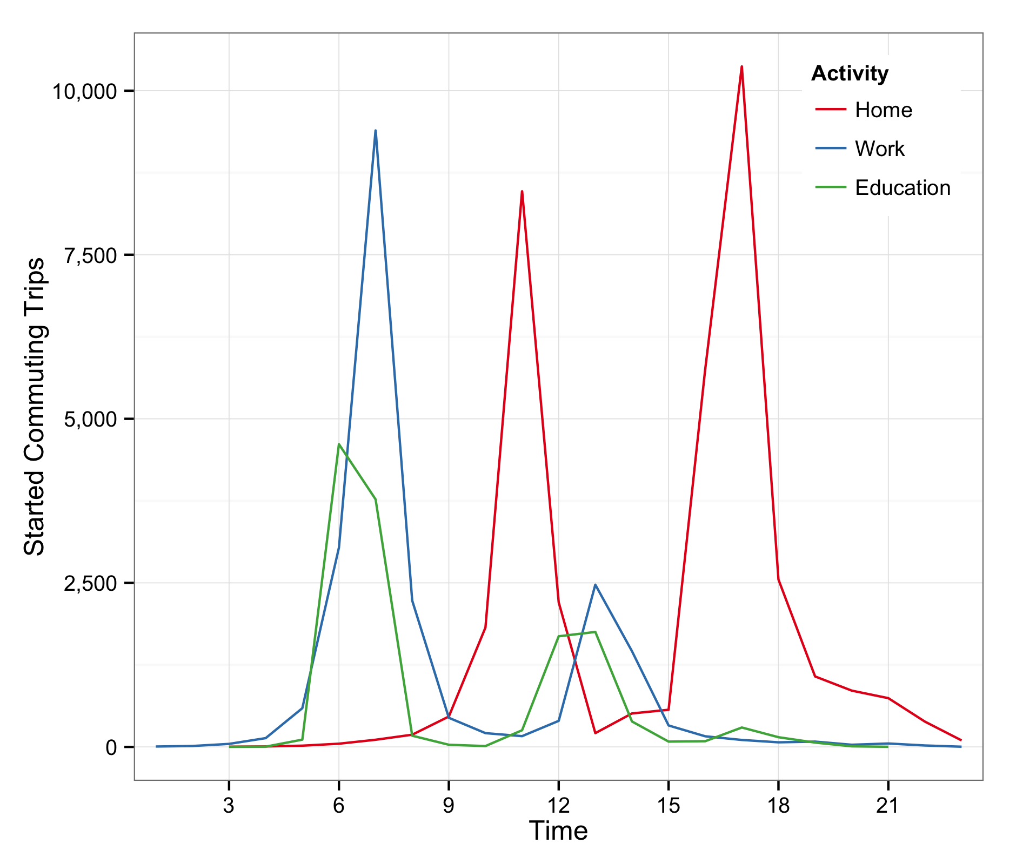 | 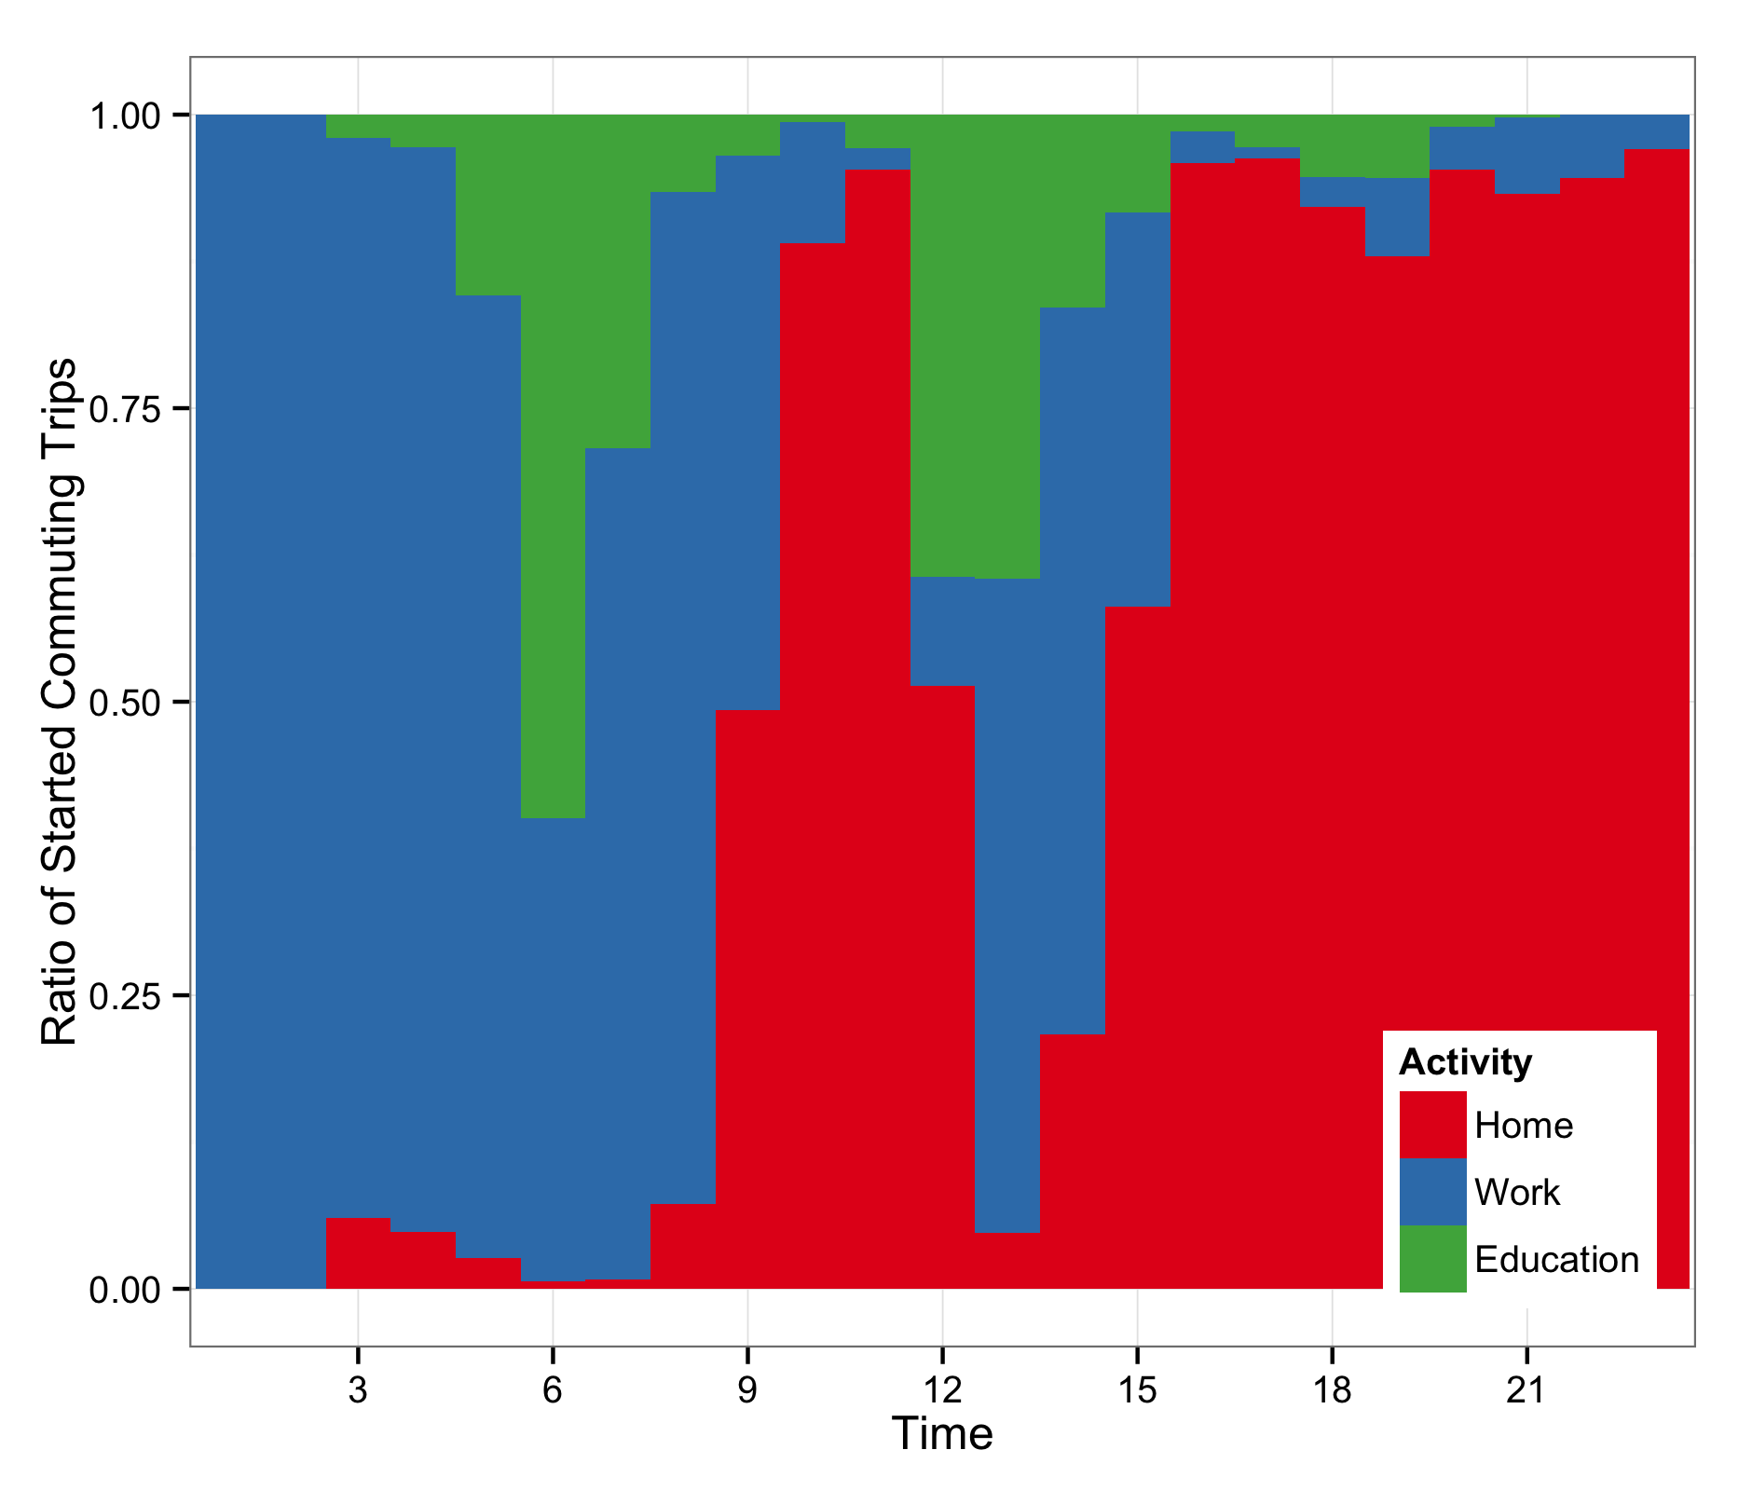 | 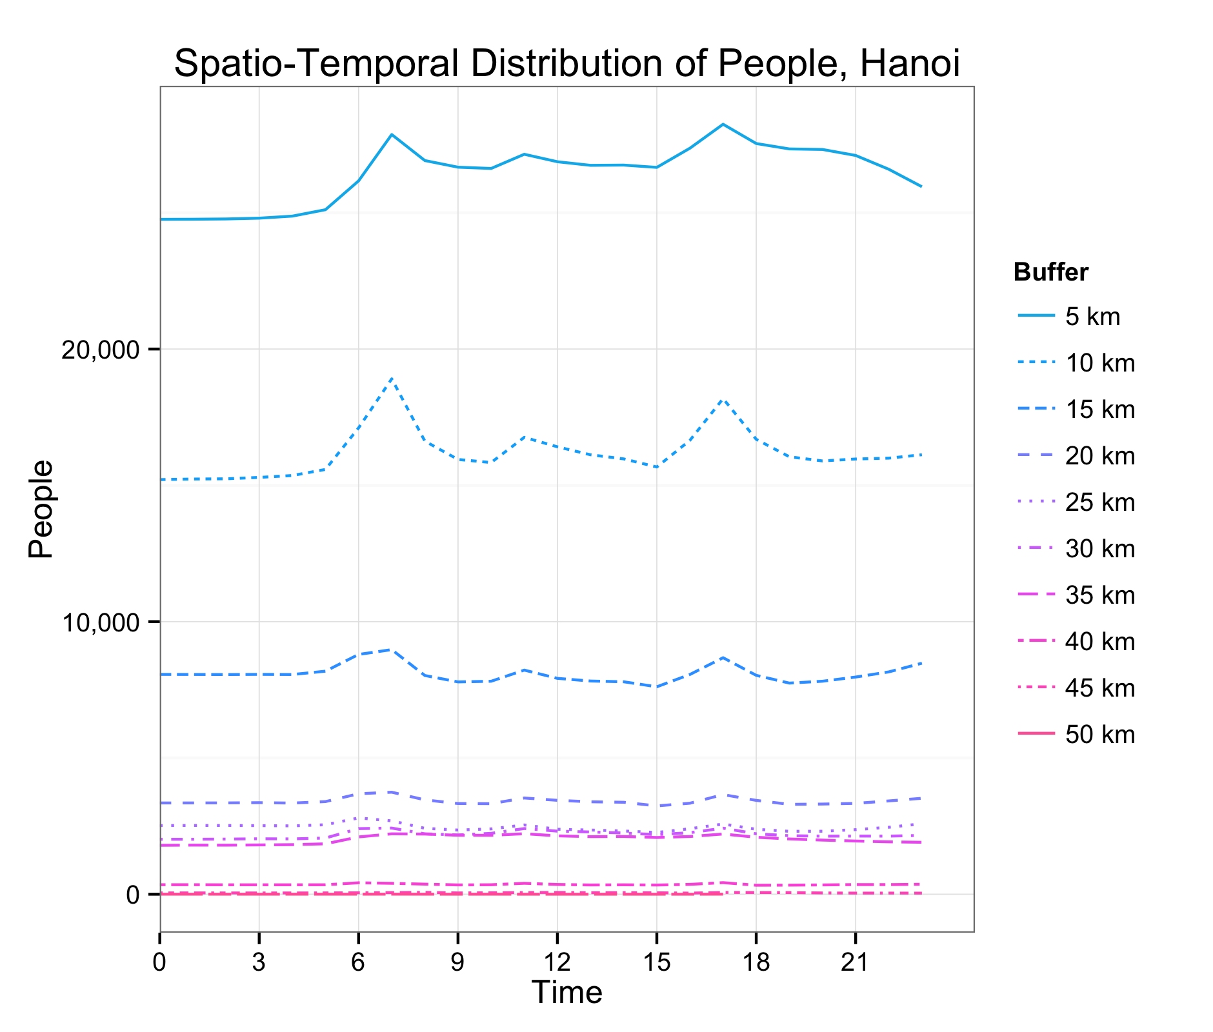 | 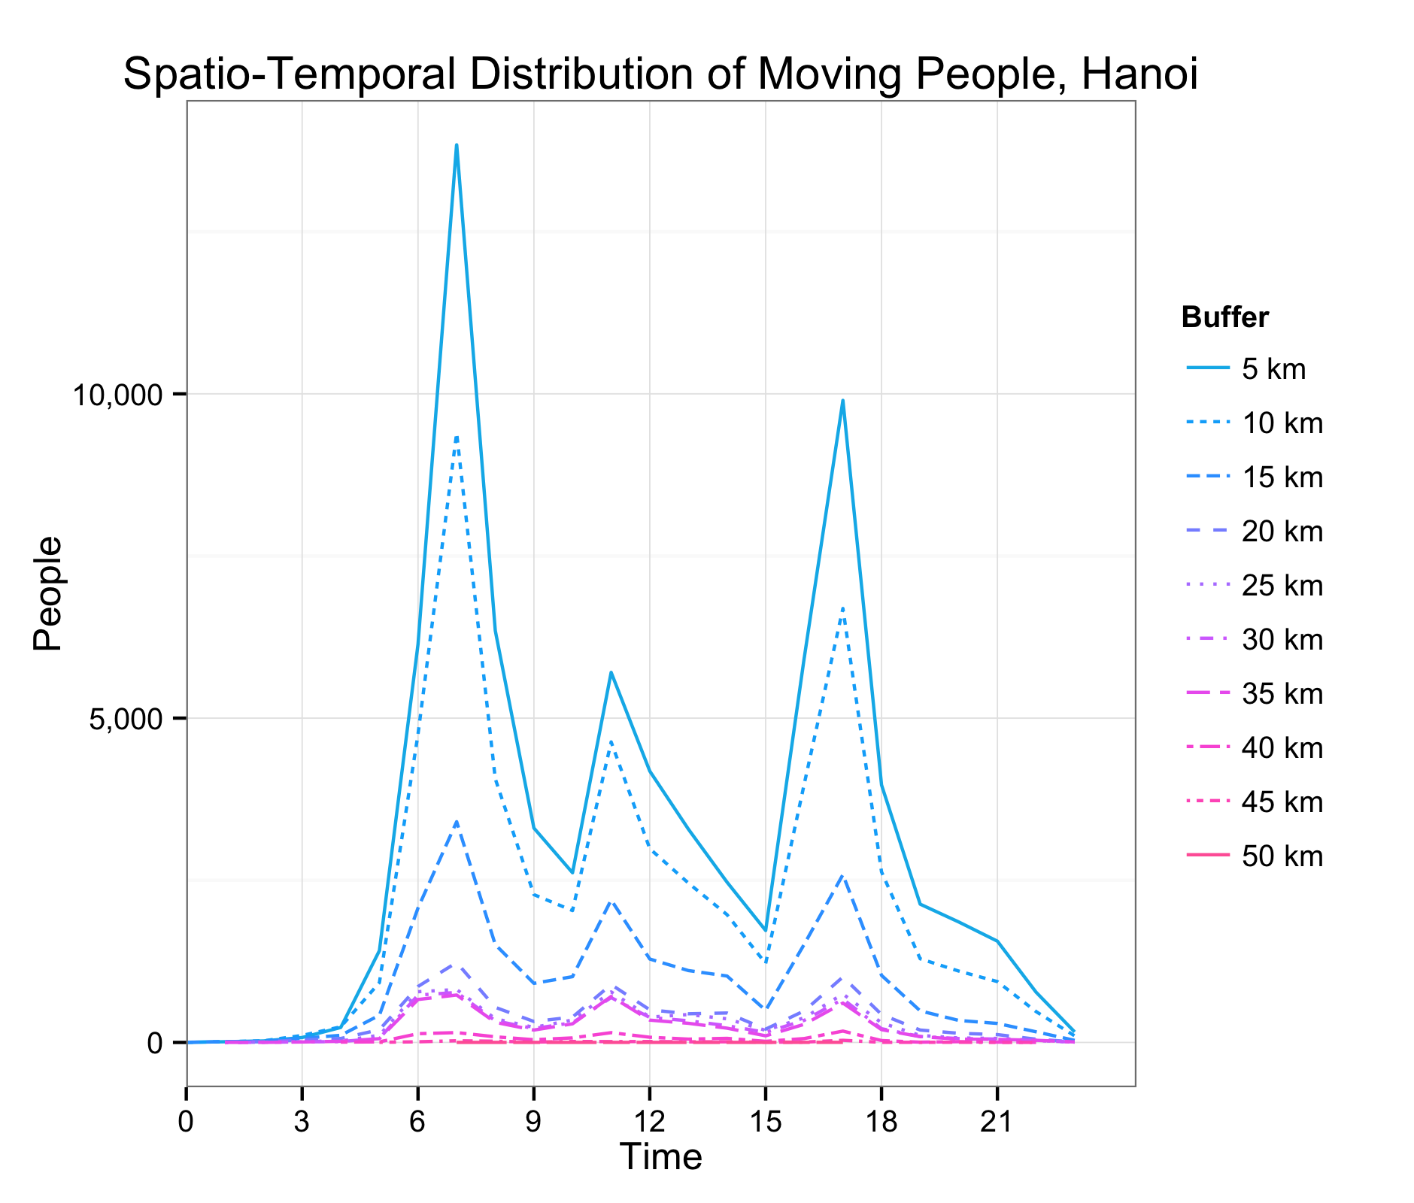
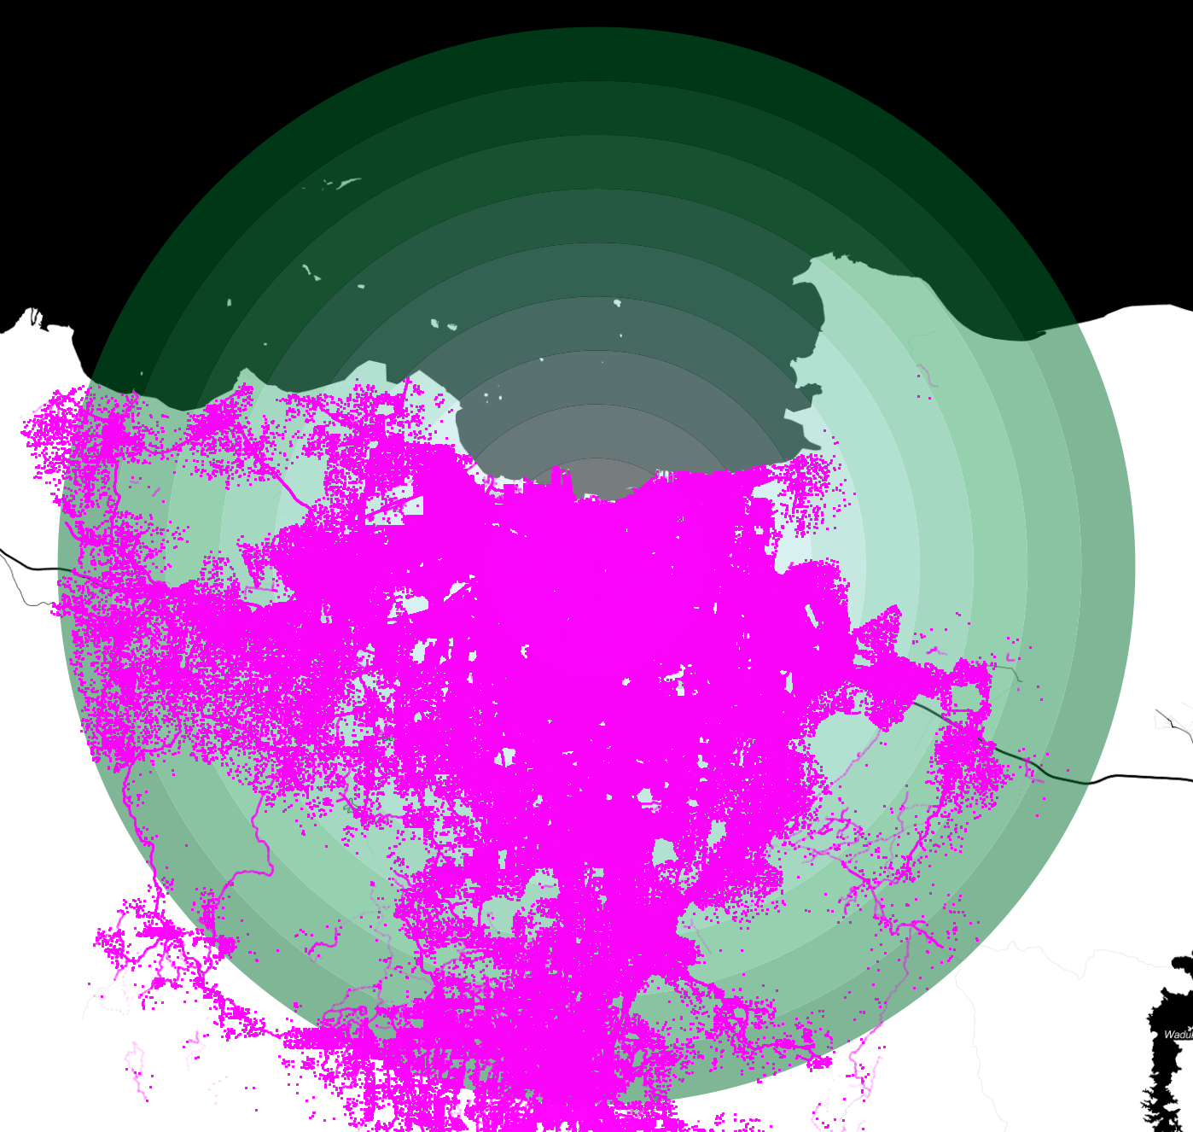  Jakarta  Data capture: 1.-2. October 2002  Individual persons: 297,043  Database size: 190.55 GB | 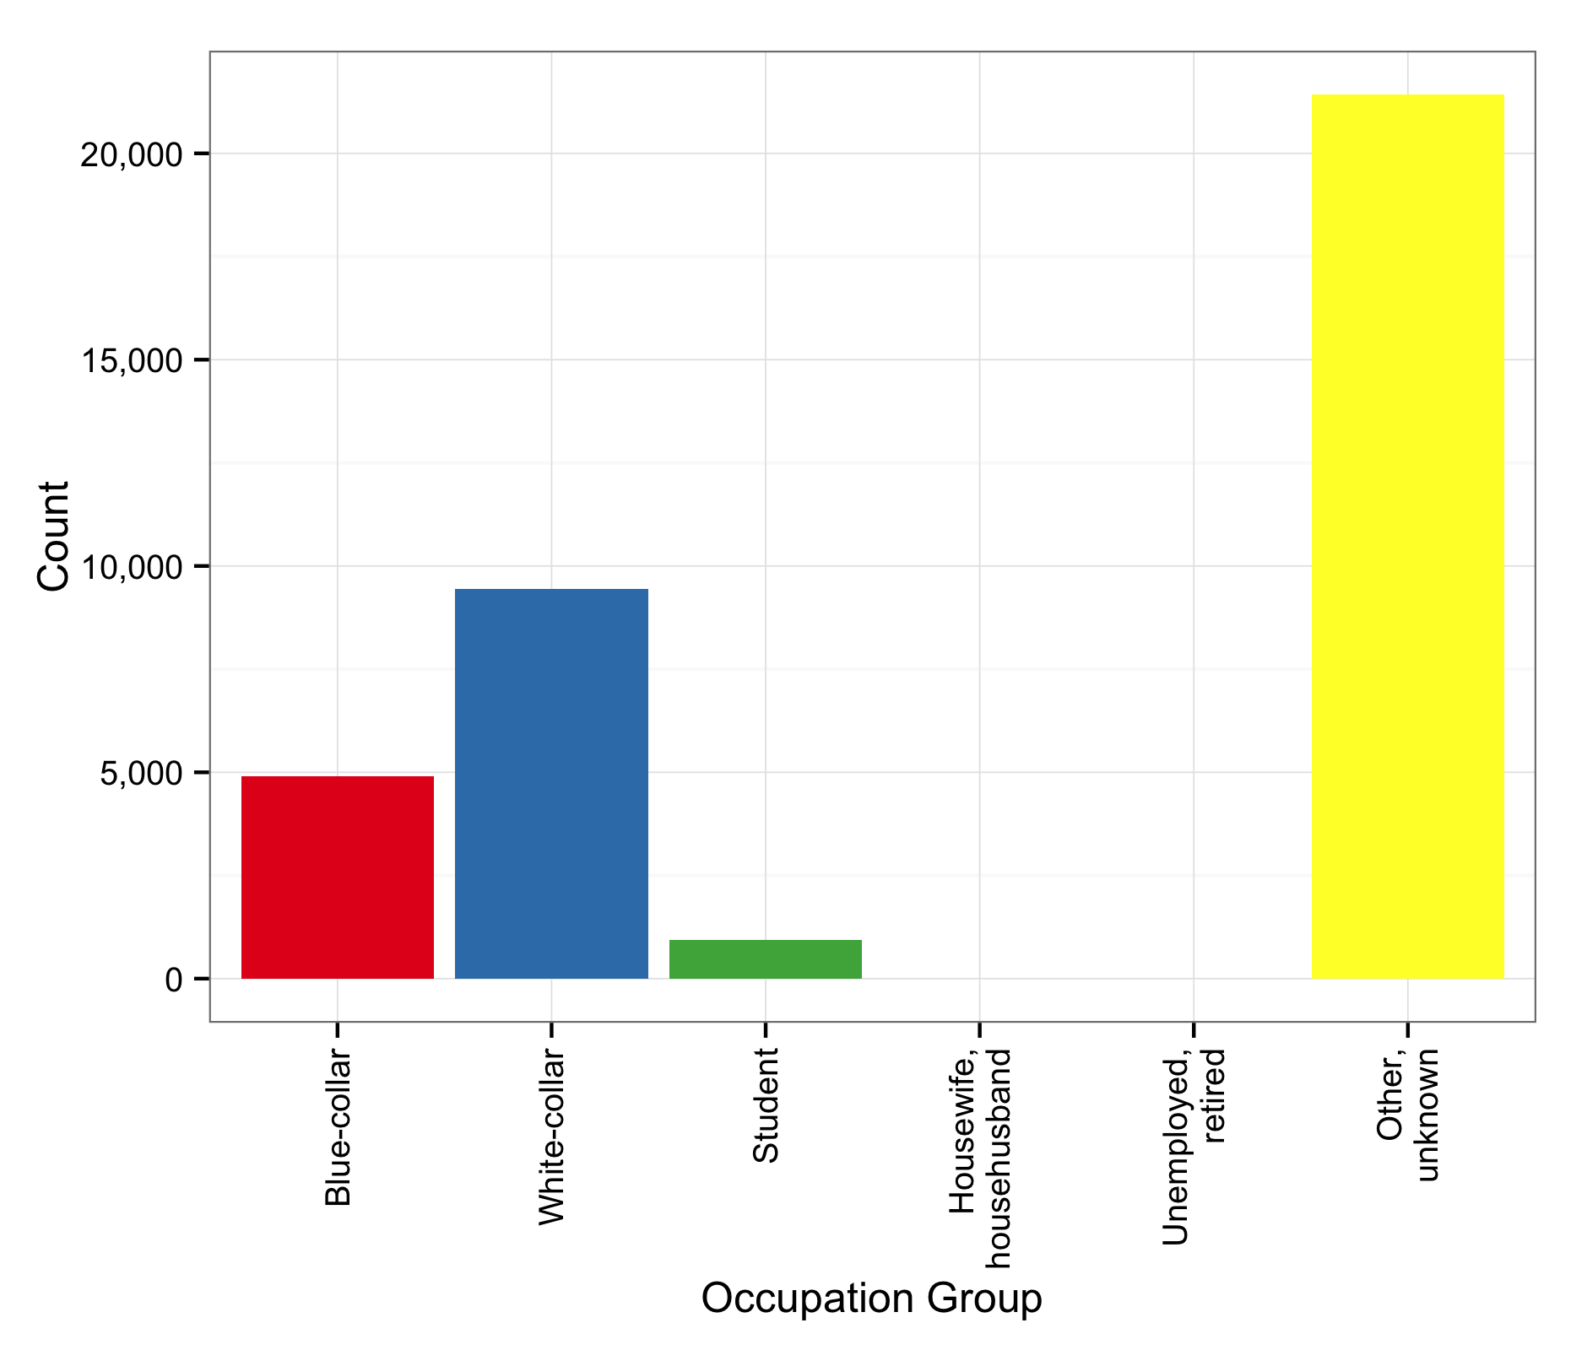 | 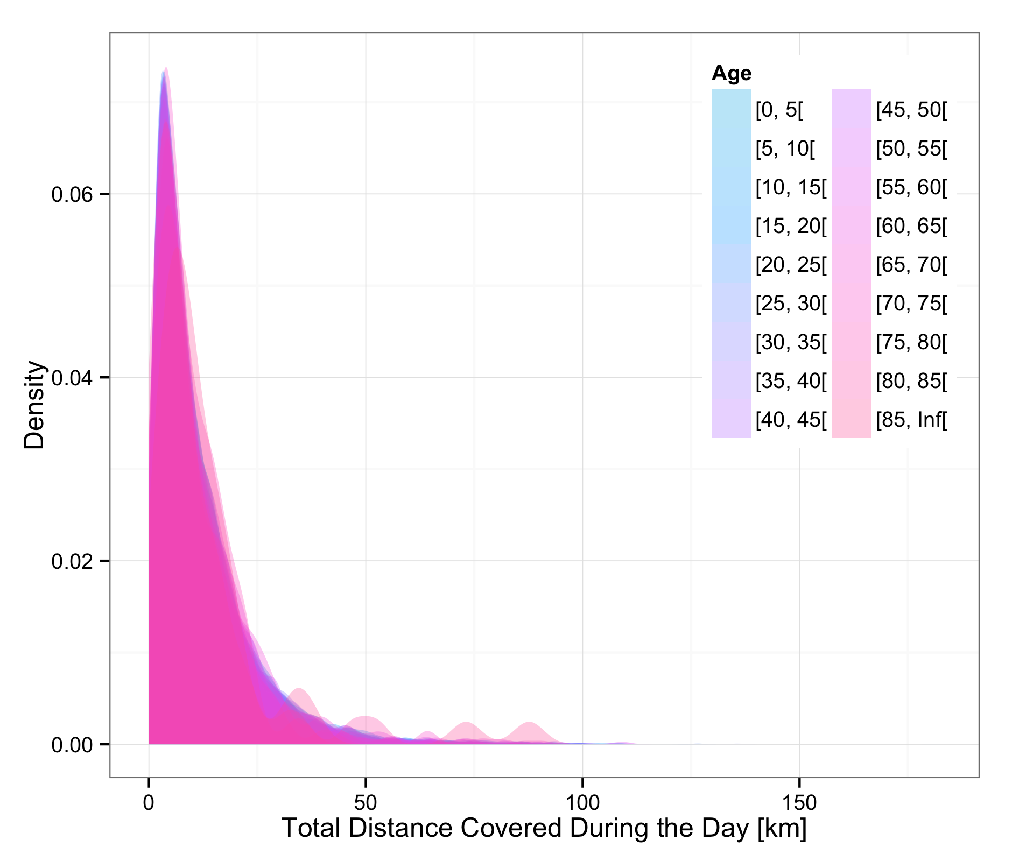 | 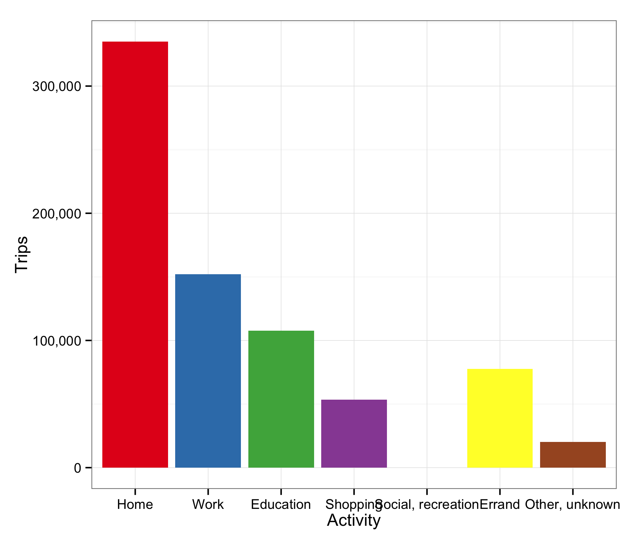 | 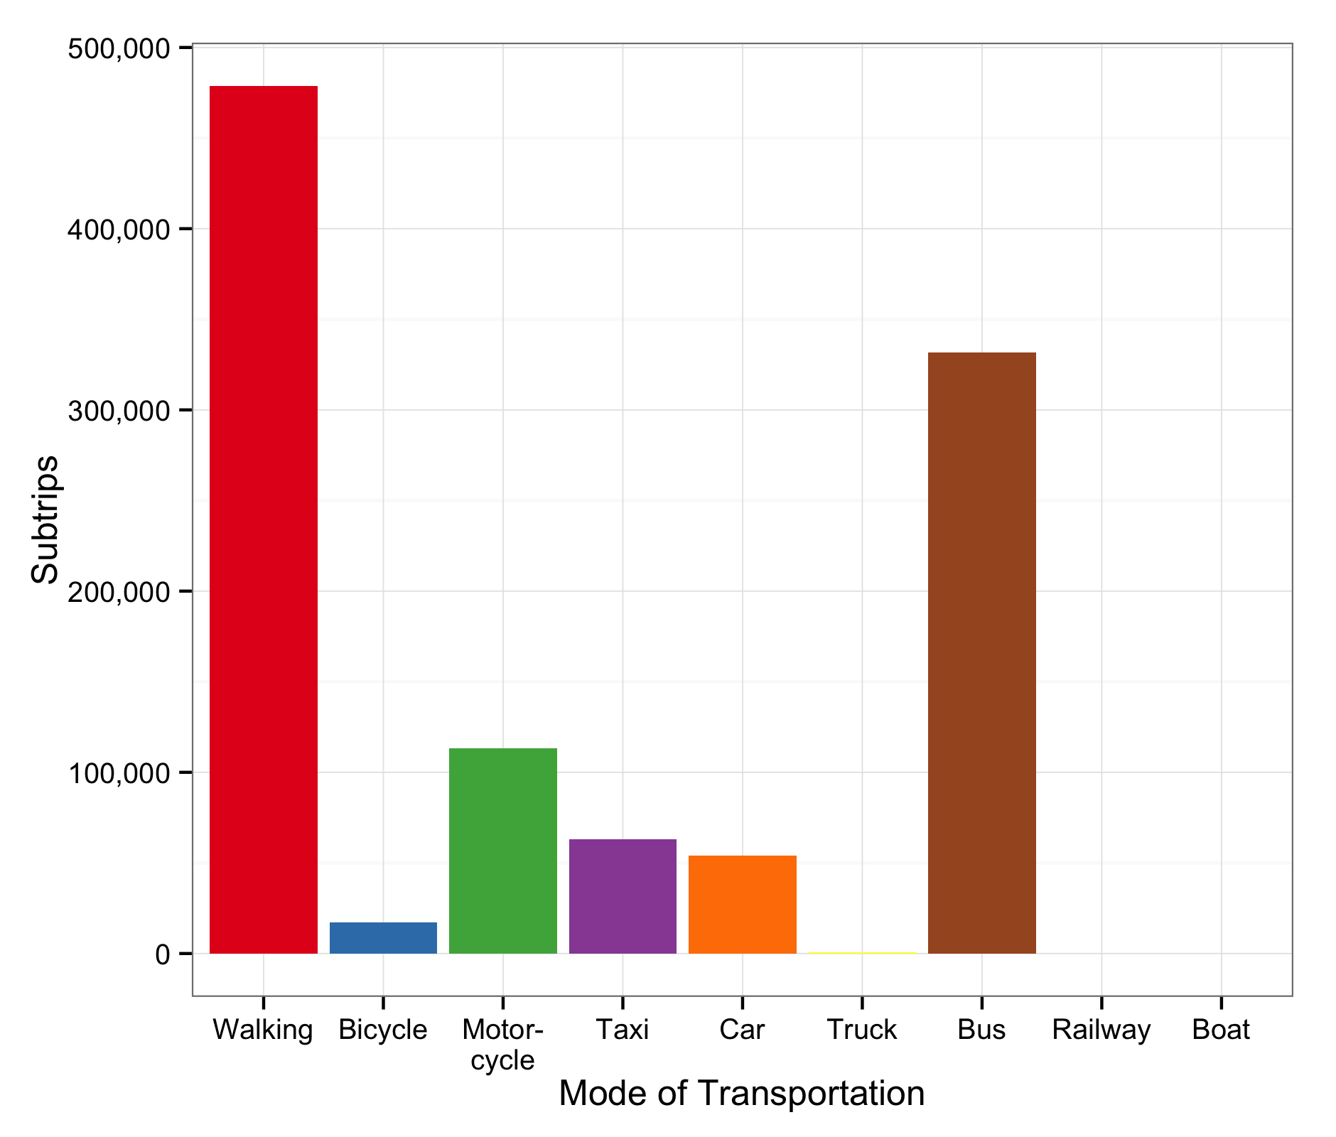
 | 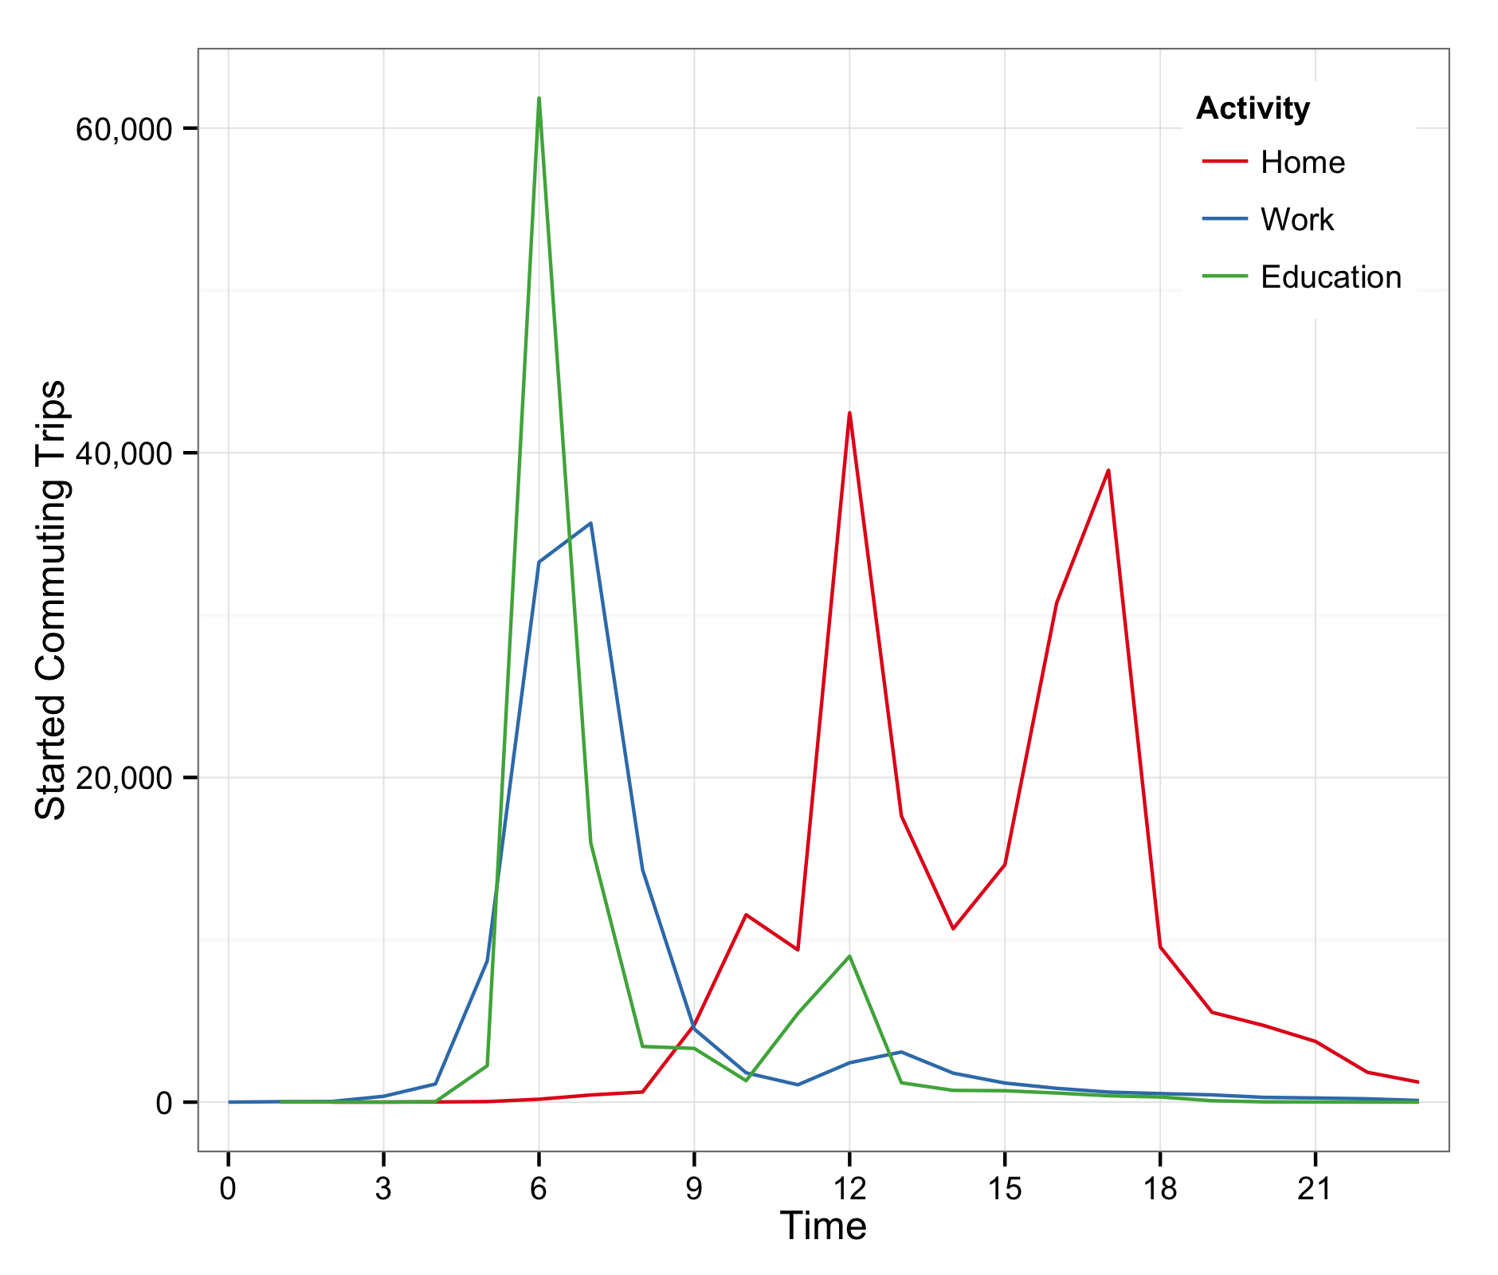 | 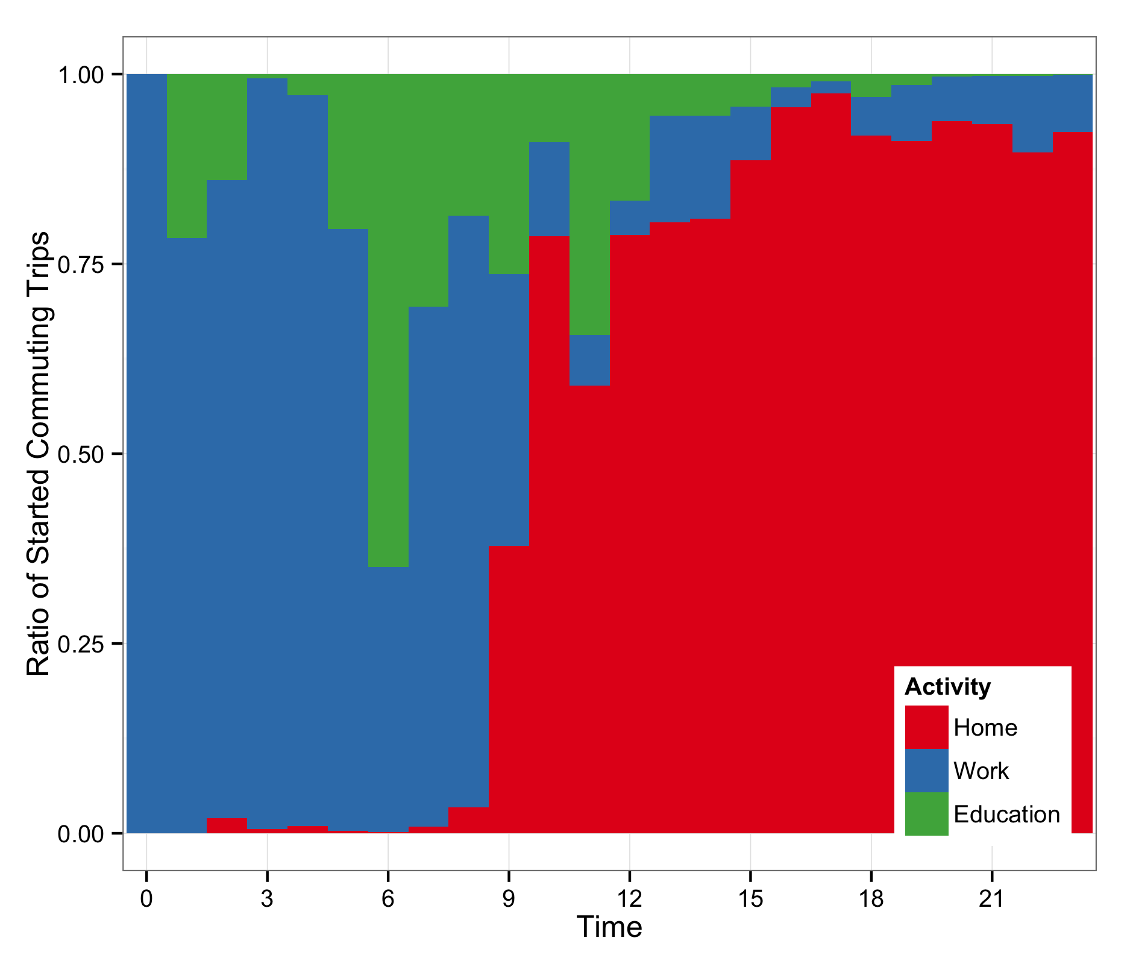 | 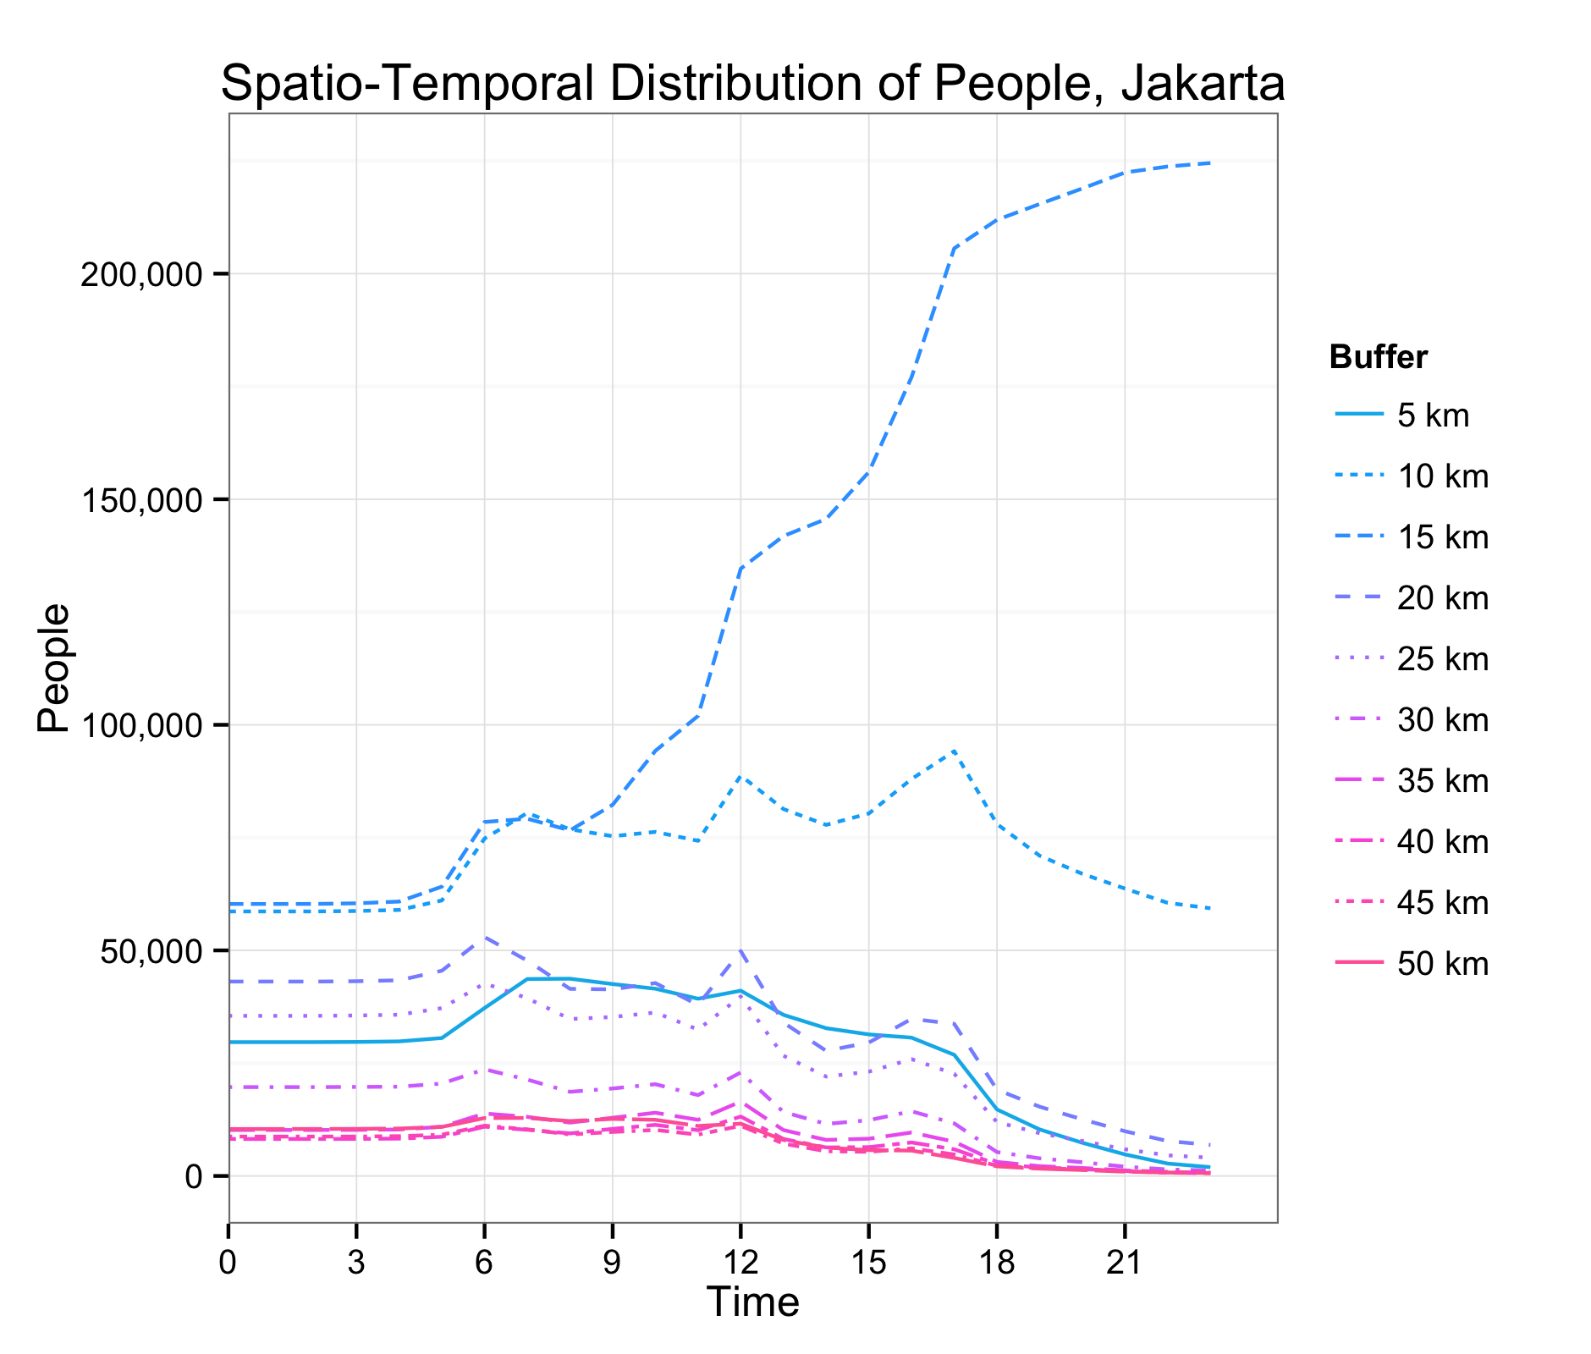 | 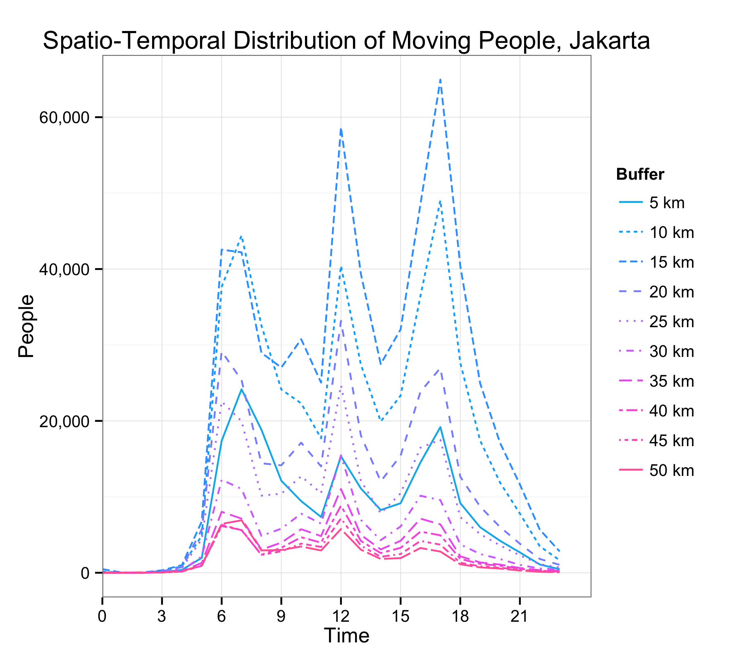
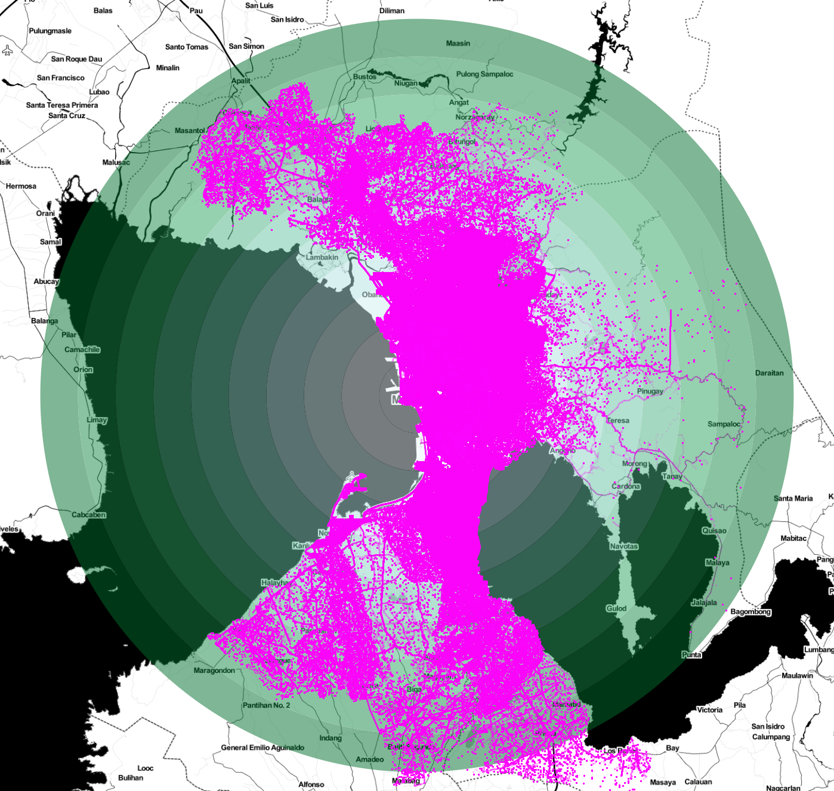  Manila  Data capture: 1.-2. October 1996  Individual persons: 189,335  Database size: 66.68 GB | 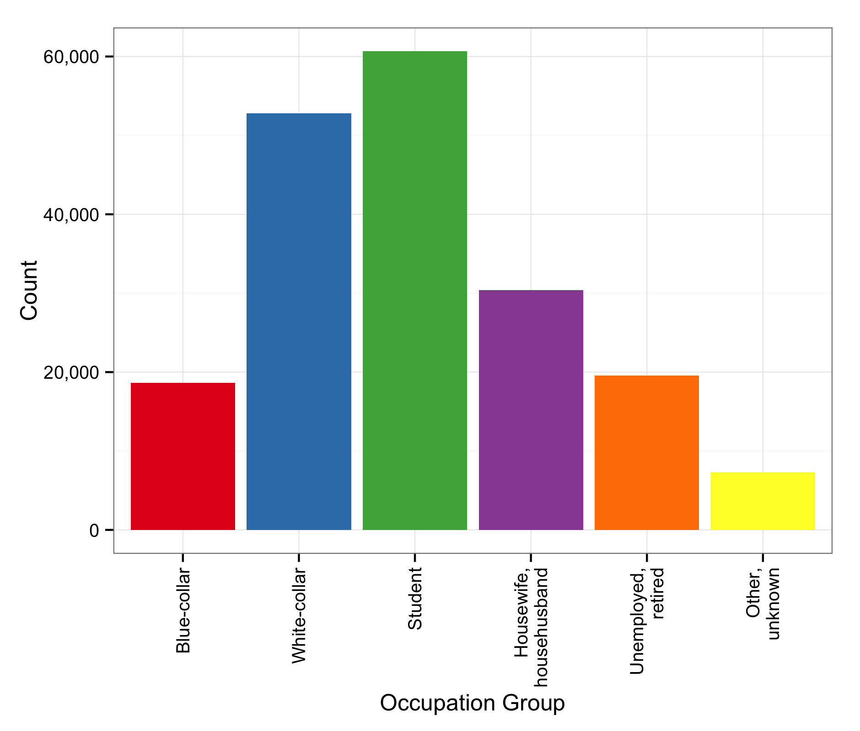 | 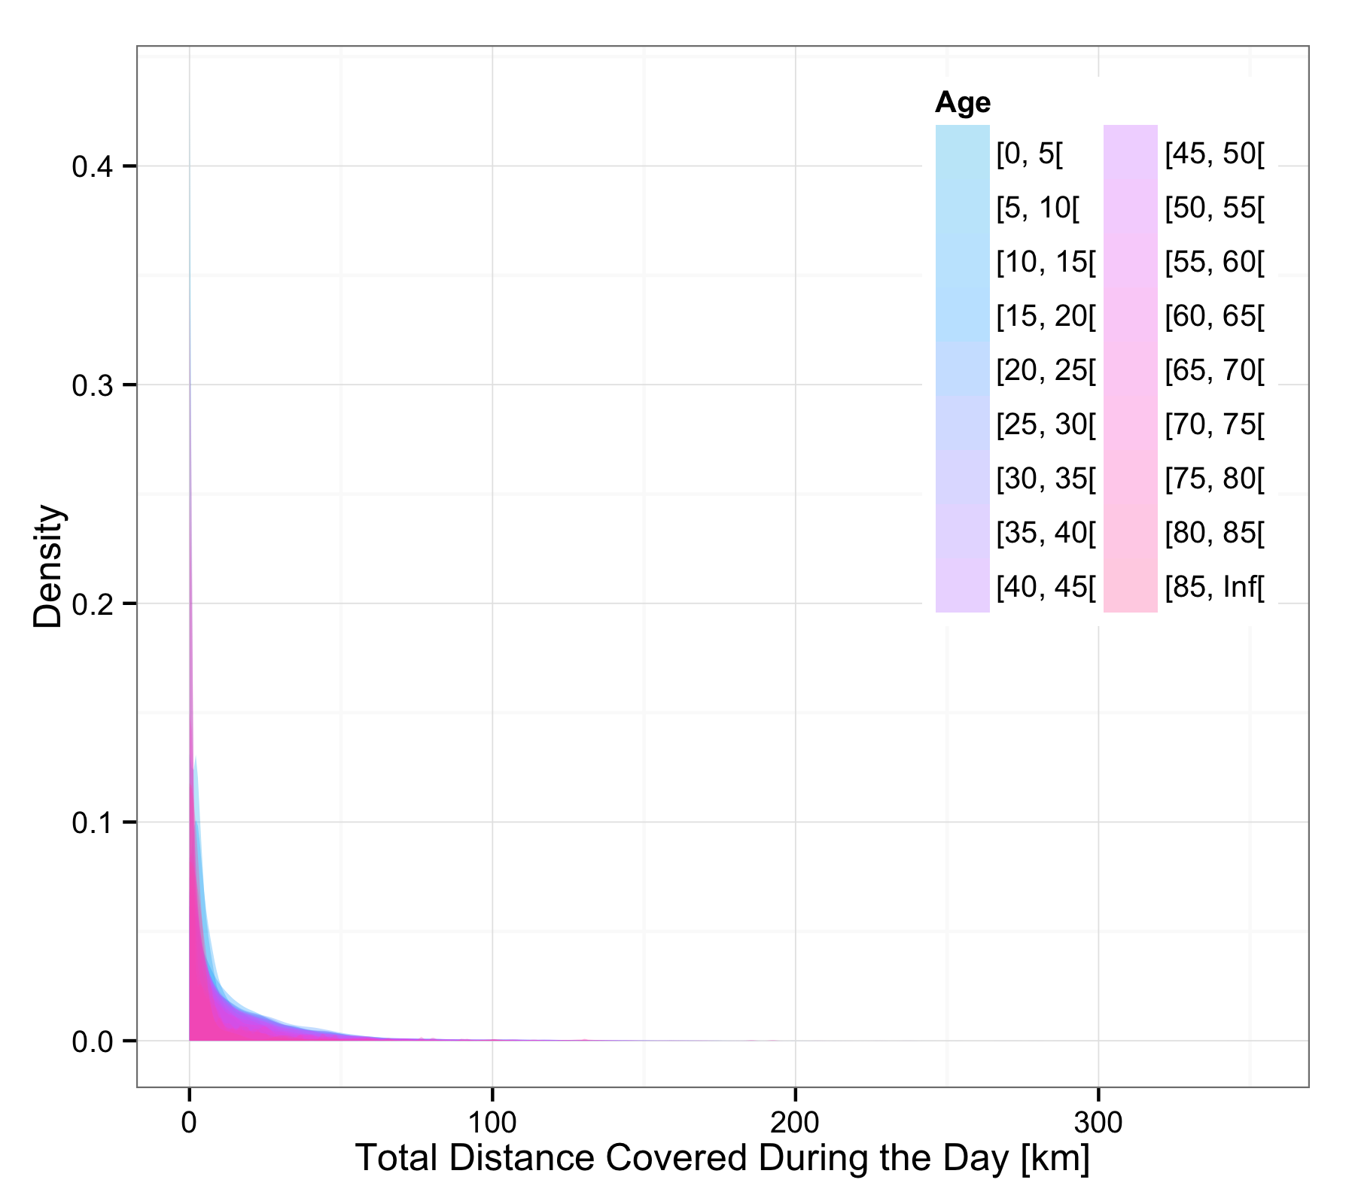 | 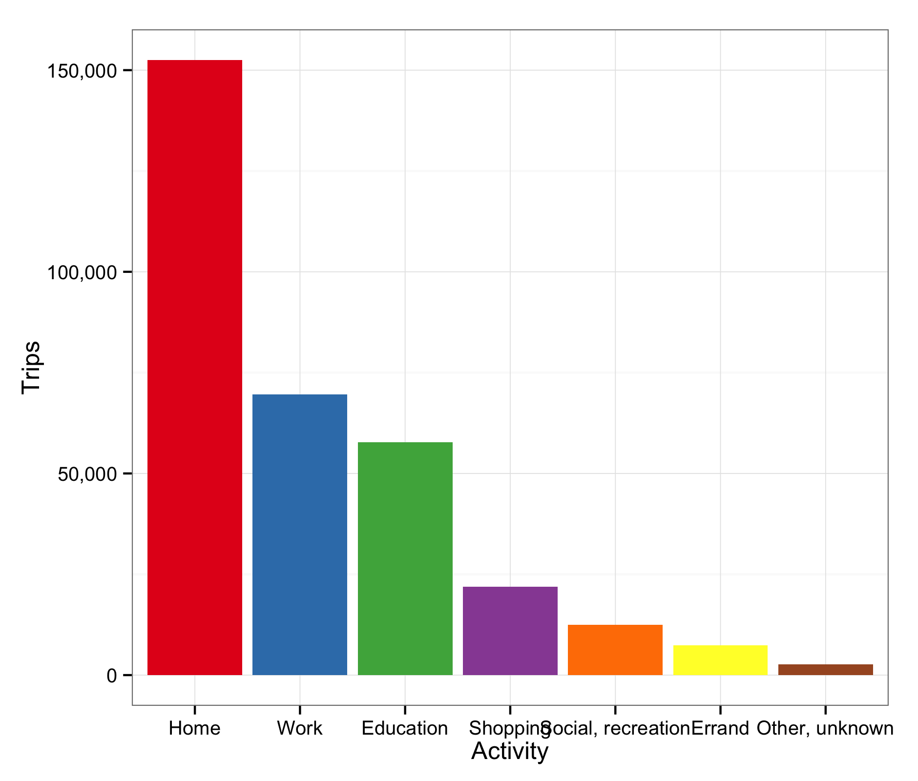 | 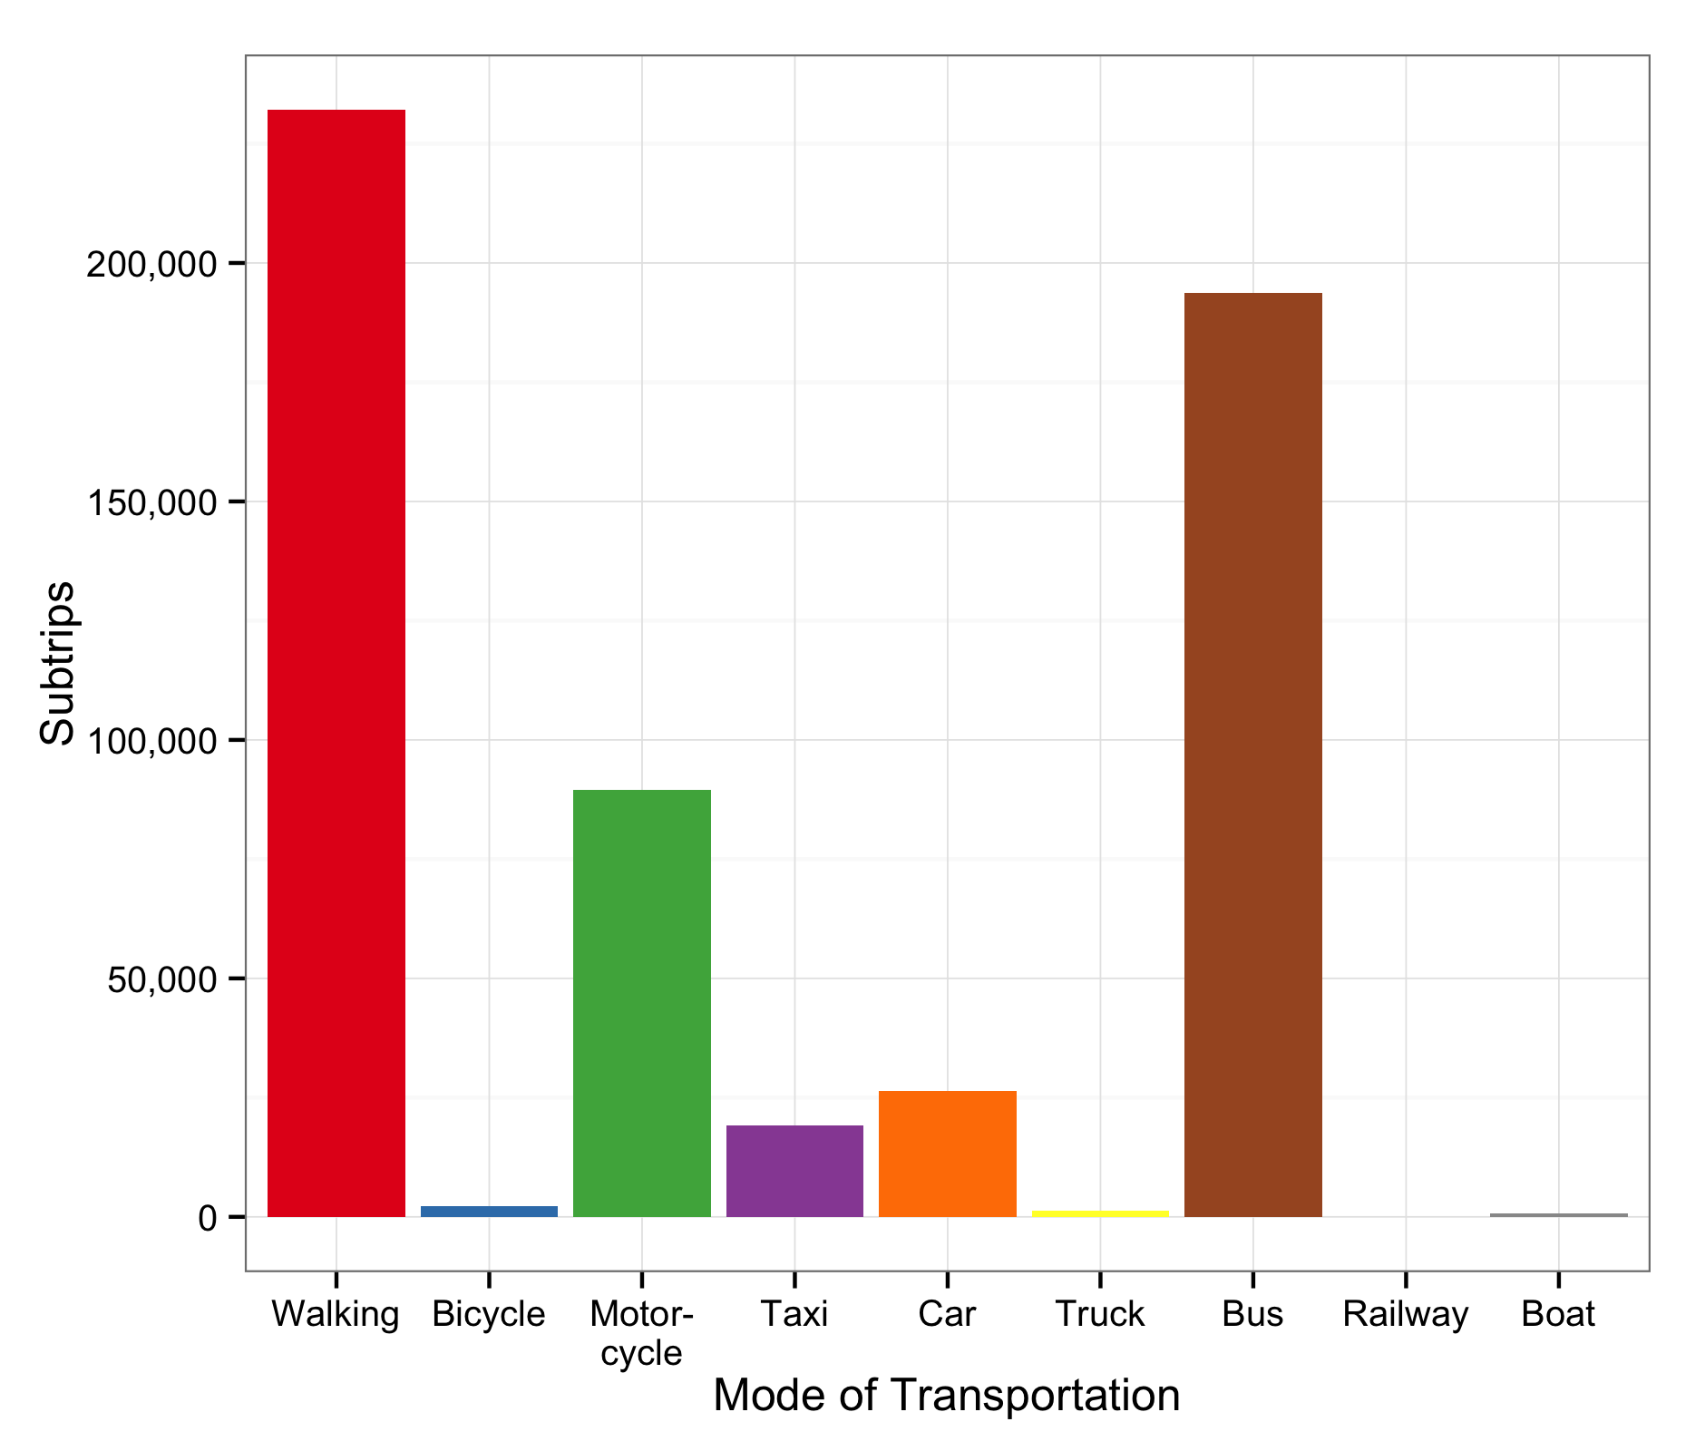
 | 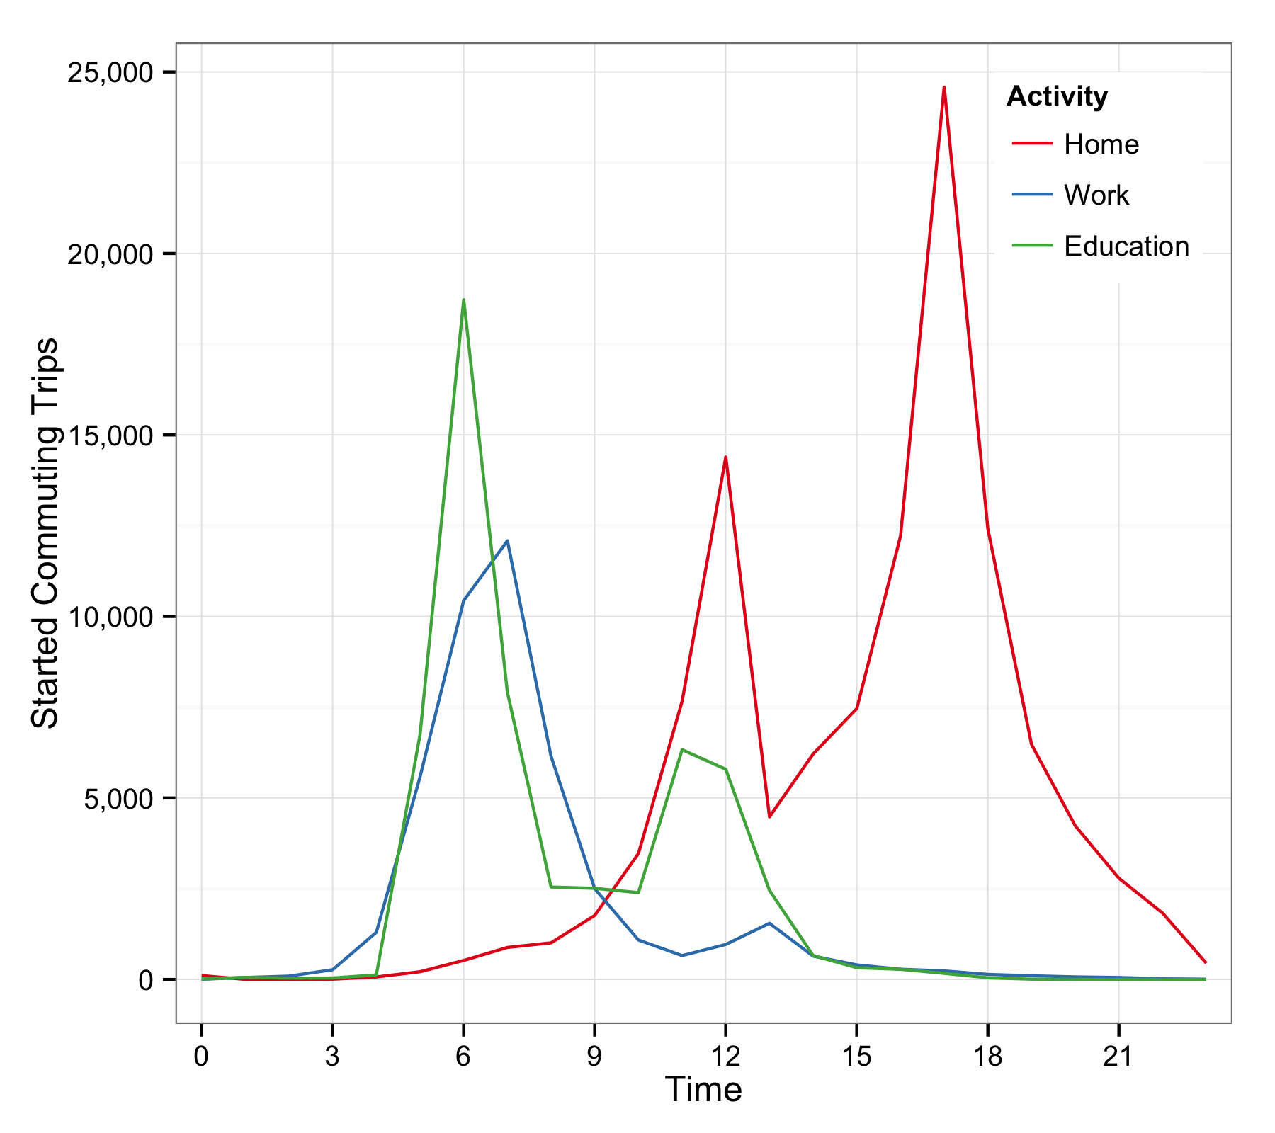 | 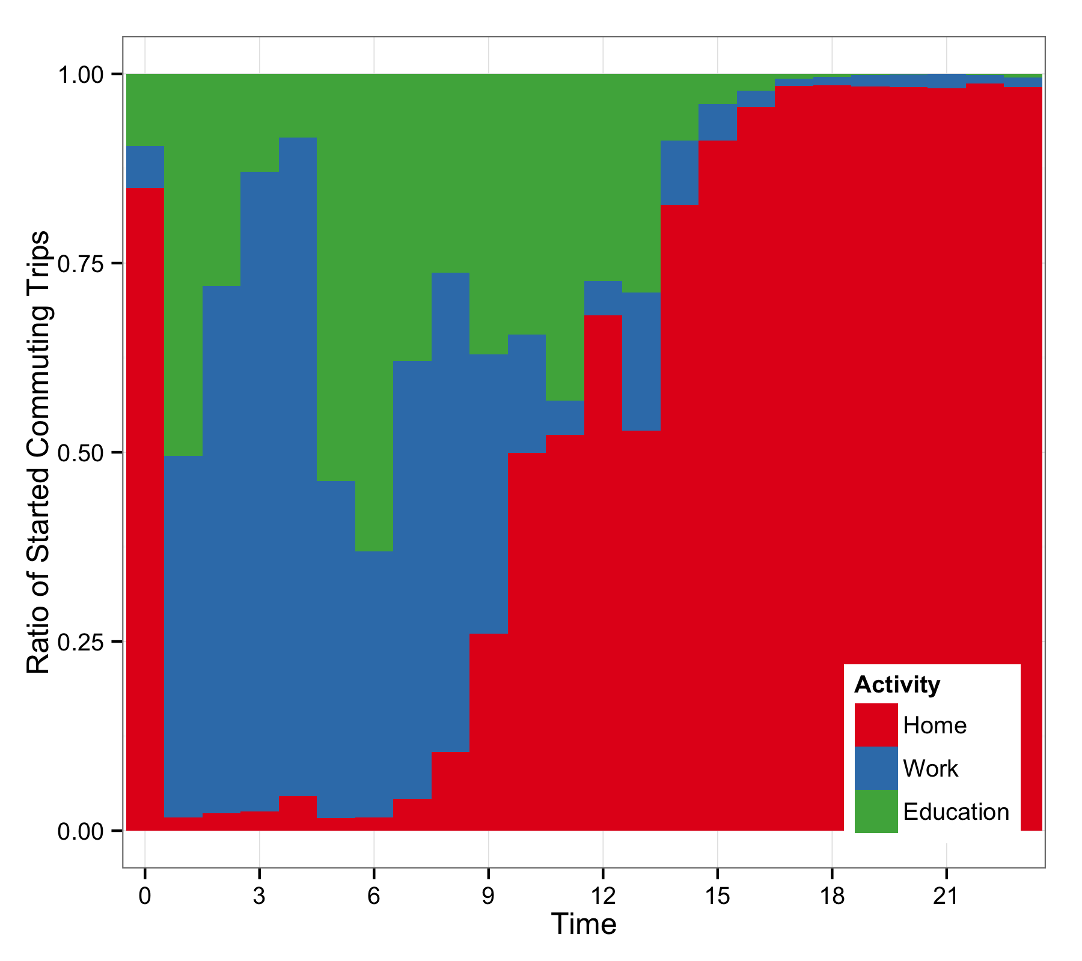 | 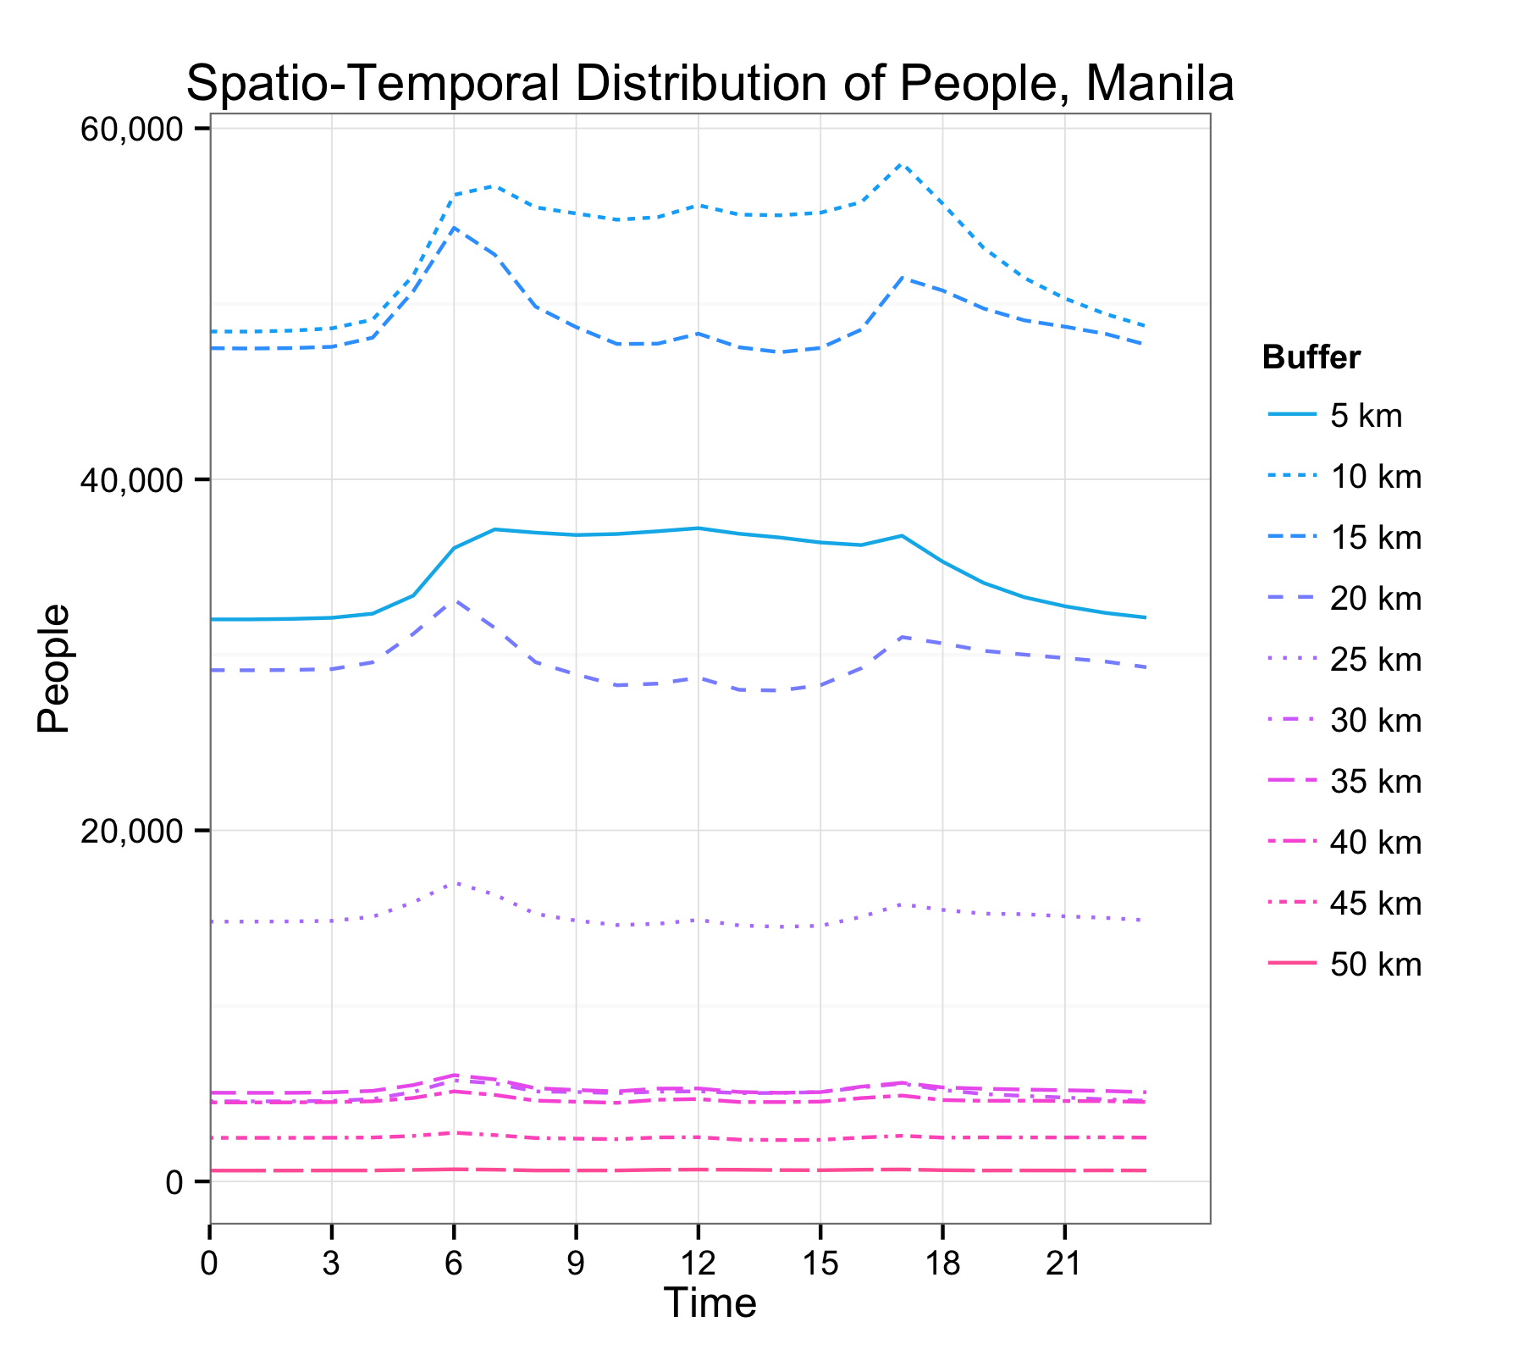 | 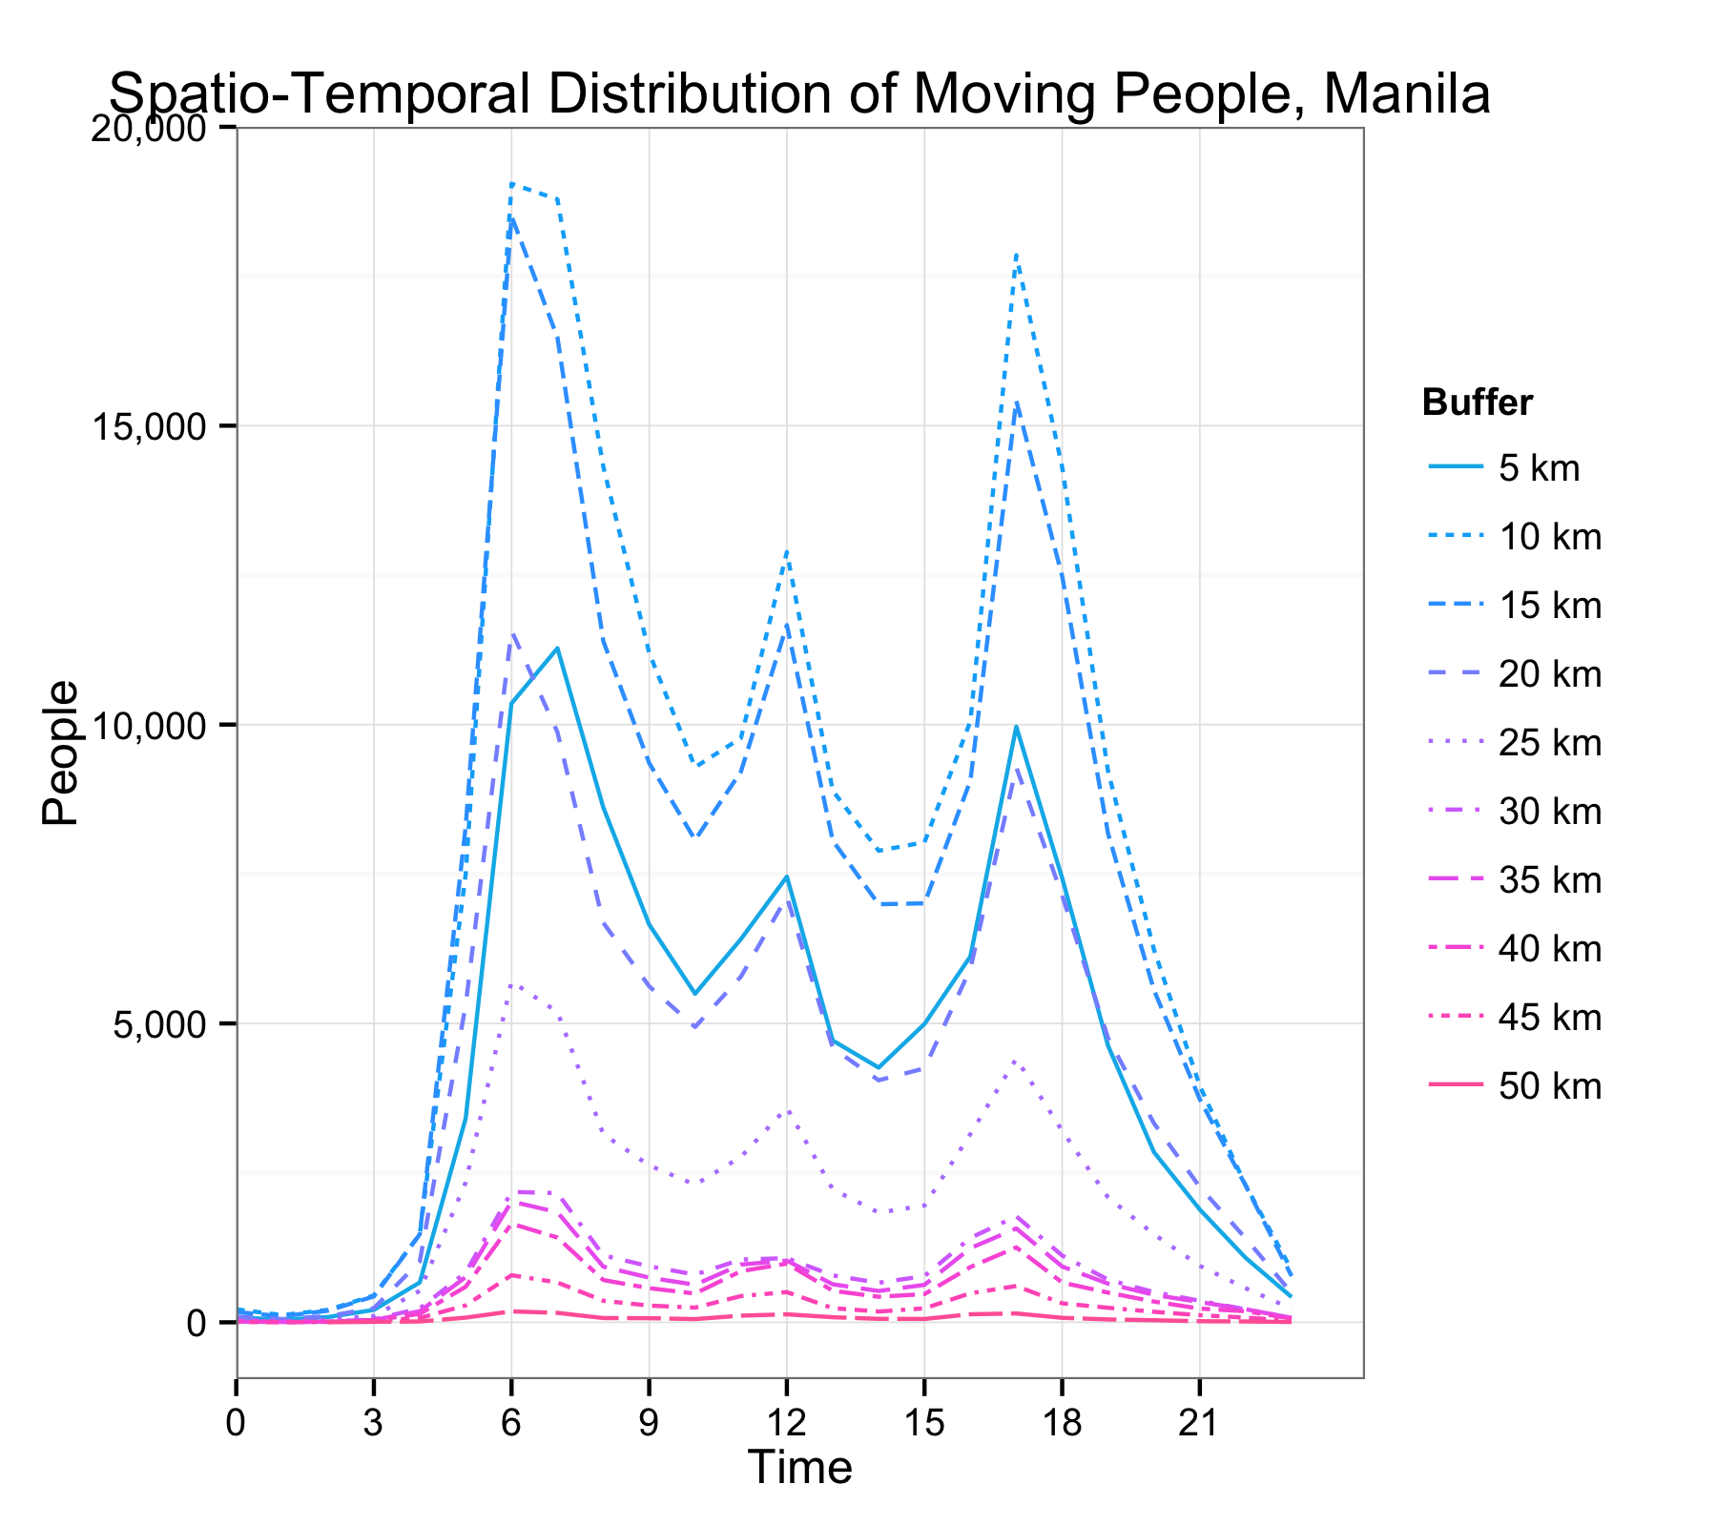
Follow this project on GitHub: https://github.com/kogreger/capital-cities

